**Docker Assignments**

1. **Difference between Virtualization and Containerization.**

**Virtualization** creates VMs. Virtual version of independent machines or computer resources created on basis of predefined configuration. Ex: separate images of Ubuntu, RHEL, AWS Linux etc. Performed using hypervisor.

**Containerization** is a lightweight process. Application is encapsulated within a container providing a minimalistic operating system. So, application uses OS of container rather than reaching out to VM/machine where container is hosted

1. **Difference between Docker attach and Exec.**

**Docker Attach Command** - The docker attach command allows you to attach to a running container using the container’s ID or name, either to view its ongoing output or to control it interactively. The command docker attach is for attaching to the existing process. It does not start any new process.

docker attach ubuntu (docker attach command using container name)

docker attach be2848539d76 (docker attach command using container id)

**Docker Exec Command** - The docker exec is specifically for running new things in an already started container. The docker exec command runs a new command in a running container, be it starting an interactive shell in a running container, or to execute arbitrary commands in the container environment.

docker exec ubuntu sh -c "echo hello && echo world"

(It runs the command by running a one-liner shell script by prefixing them with the executable *sh -c* with container name)

1. **Difference between Docker Stop and Kill.**

**Docker Stop Command** - The docker stop command stops the container gracefully and provides a safe way out.

docker stop be2848539d76 (docker stop command using containerId)

docker stop hello-world (docker stop command using the container name)

**Docker Kill Command** - The docker kill command terminates the entry point process abruptly. The docker kill command causes an unsafe exit.

docker kill be2848539d76 (docker kill command using containerId)

1. **Docker Commands List**

* docker info (Display system-wide information)

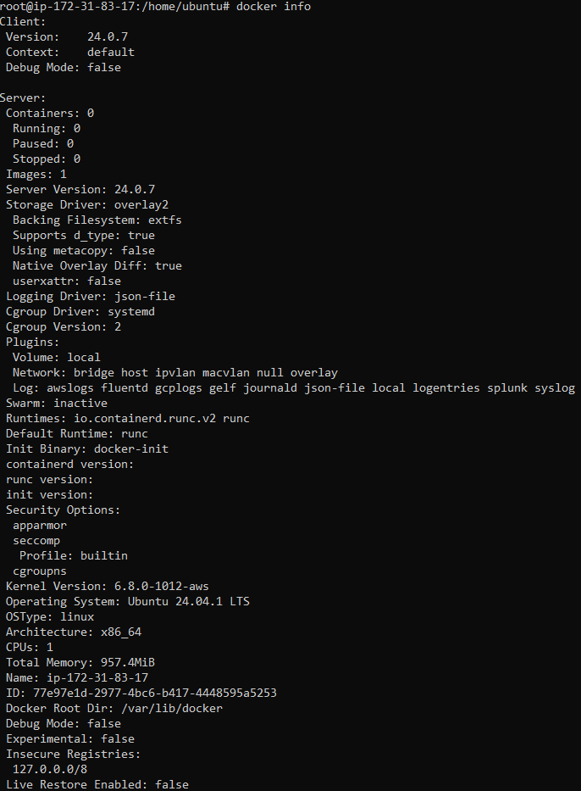

* docker --help (Get help with Docker)

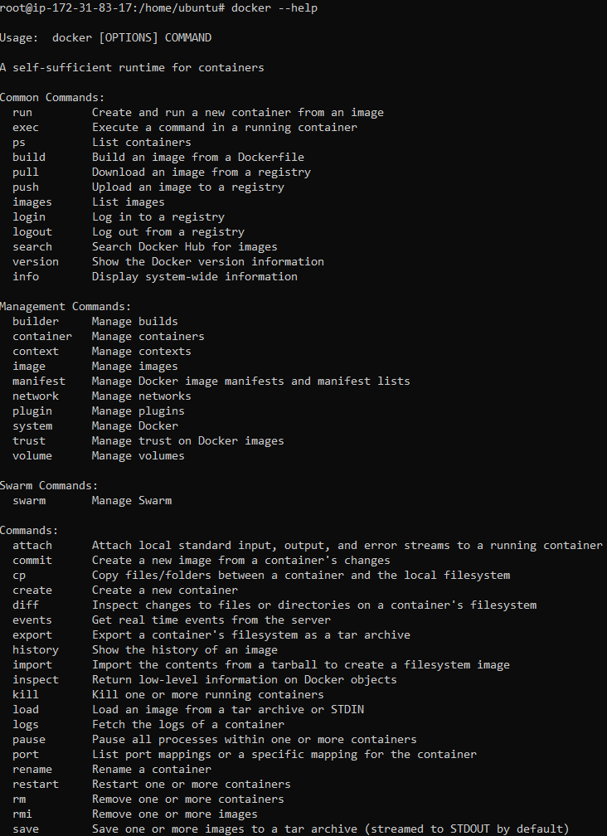

* docker pull <image\_name> (Pull an image from a Docker Hub)

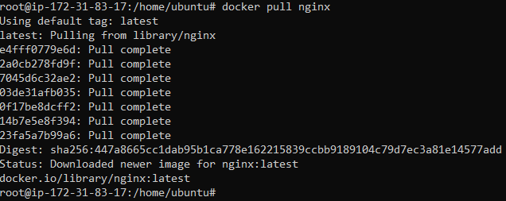

* docker search <image\_name> (Search Hub for an image)

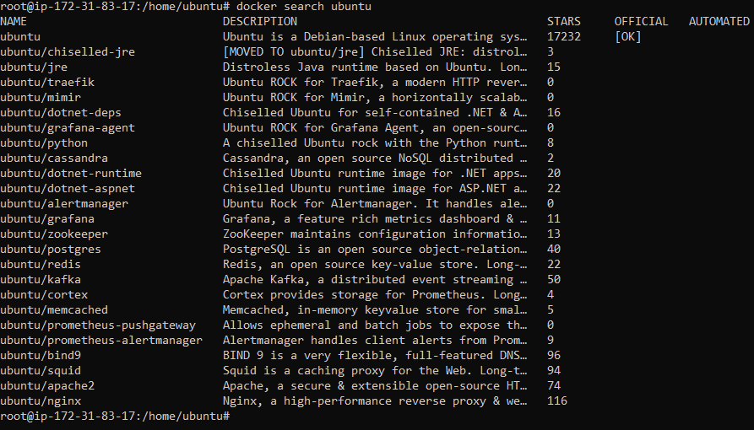

* docker images (List the images that have been downloaded)

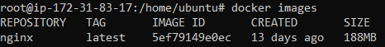

* docker image rm <image\_name> (Removing a Docker Image)

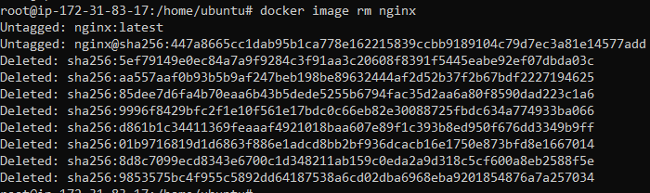

* docker run <image\_name> (Pulls the image from docker hub and runs a container from the image)

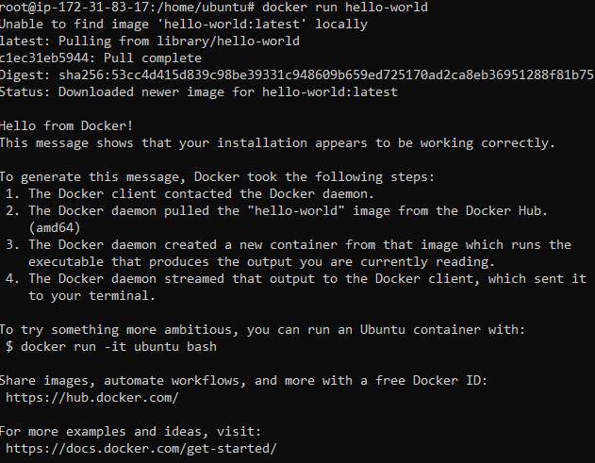

* docker ps -a (Show all containers)



* docker version (Echoes Client’s and Server’s Version of Docker)

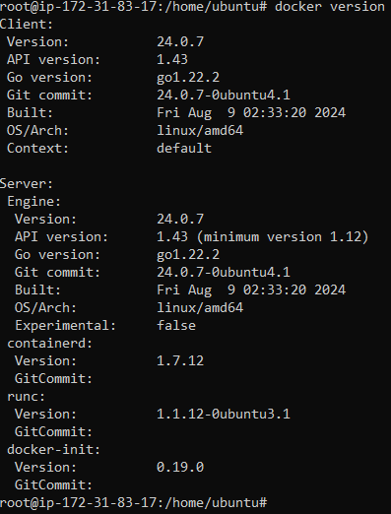

* docker start <container\_Id> (Starts one or more stopped containers)



* docker ps -l (Show latest container)



1. **Docker Swarm Commands**

* docker swarm init –advertise-addr 192.168.10.1 (Initializing the Swarm)

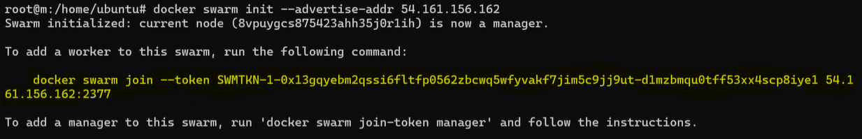

* docker swarm join-token worker (Getting a Worker to Join the Swarm)



* docker service ls (Listing Services)

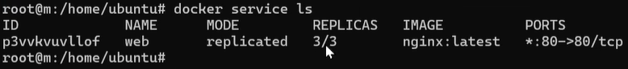

* docker node ls (Listing Nodes)

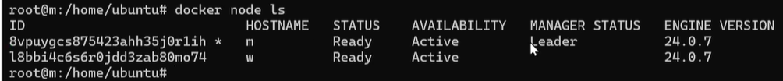

* docker service create –name vote -p 8080:80 instavote/vote (Creating a Service)

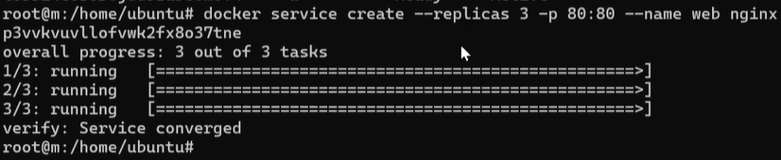

* docker service scale vote=3 (Scaling a Service)

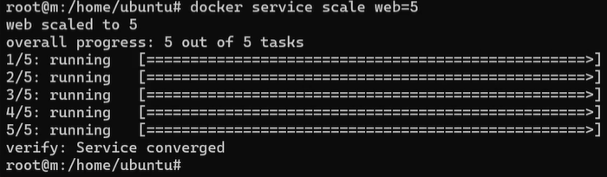

1. **Docker monitoring commands.**

* wget <https://github.com/bcicen/ctop/releases/download/v0.7.1/ctop->0.7.1-linux-amd64 -O /usr/local/bin/ctop (Installation of ctop monitoring tool)



chmod +x /usr/local/bin/ctop



* ctop (ctop command to view the usage of docker swarm)



* ctop -a (To display active containers only)



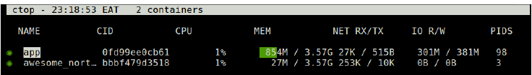

* ctop -scale-cpu (To display CPU as **%** of system total)

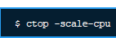

* ctop -f app (Filter any containers)

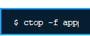

* ctop -h (This command is for ctop help)



1. **Docker container log file and home path location.**

* Docker container log file location

/var/lib/docker/container

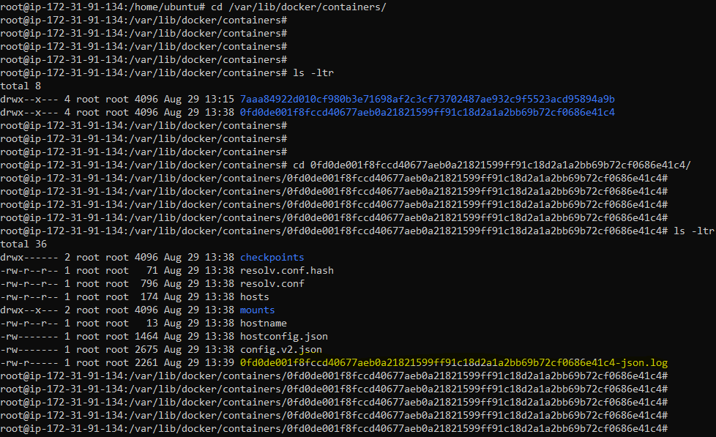

* Docker home path location

/var/lib/docker

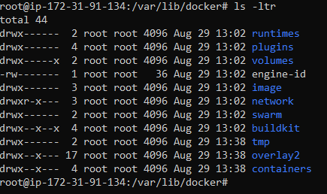

1. **Image has been downloaded in docker we need to know where it is referenced/maintained.**

/var/lib/docker/image/overlay2

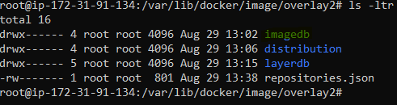

1. **Install docker old version and upgrade to new version**

* Create a new EC2 instance with ubuntu image and run

apt update -y && apt upgrade -y

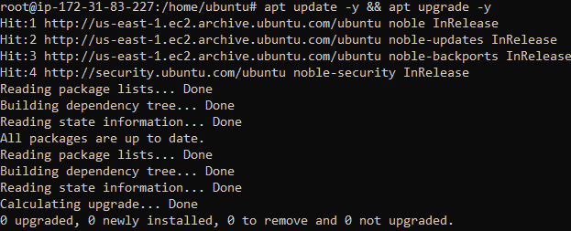

* Download the old version static binary archive by running the below wget command and choose your hardware platform, and download the .tgz file relating to the version of Docker Engine you want to install.

wget https://download.docker.com/linux/static/stable/x86\_64/[docker-20.10.9.tgz](https://download.docker.com/linux/static/stable/x86_64/docker-19.03.9.tgz)

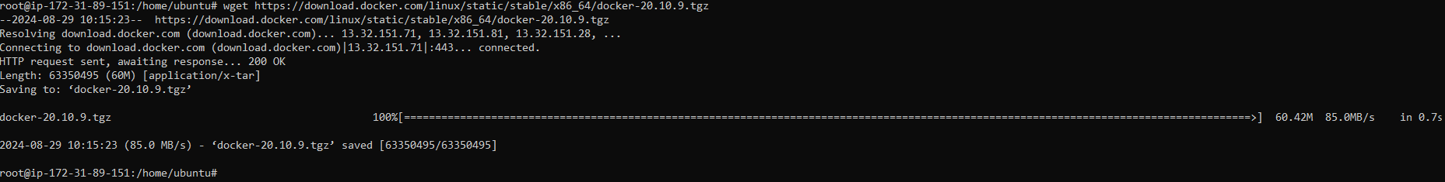

ls -ltr to check if the file is downloaded

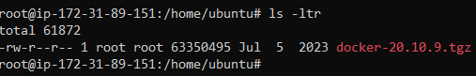

* Extract the archive using the tar utility. The dockerd and docker binaries are extracted.

tar xzvf docker-20.10.9.tgz

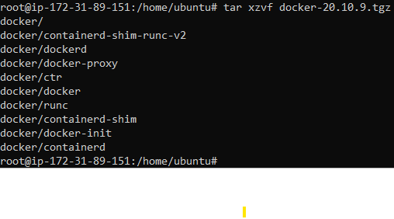

ls -ltr to check if the tar file is extracted.

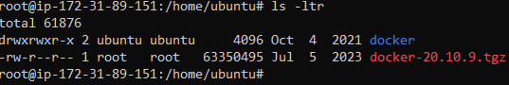

* Move the binaries to a directory on your executable path, such as /usr/bin/

cp docker/\* /usr/bin/



* Start the Docker daemon

dockerd &

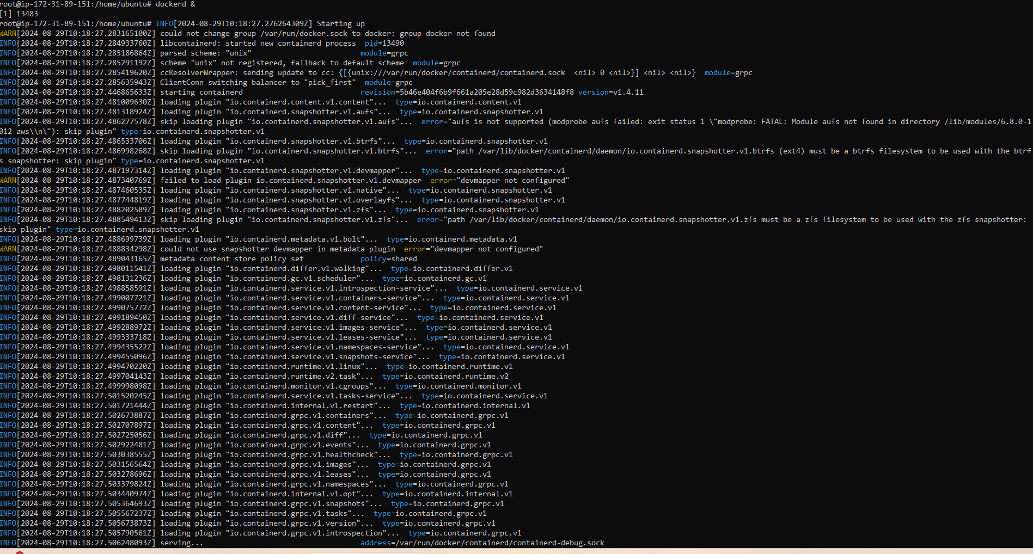

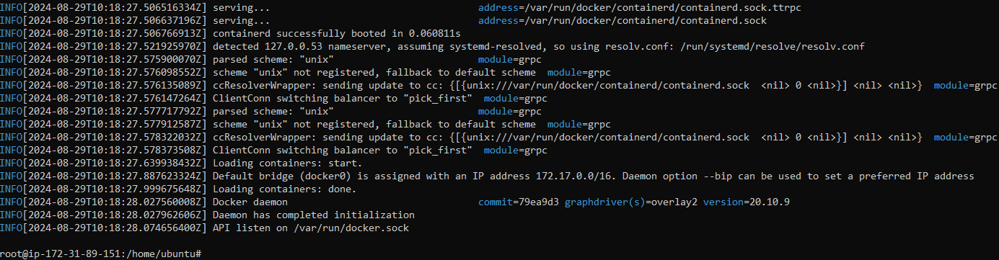

* We will verify the version of docker installed, shows 20.10.9

docker --version

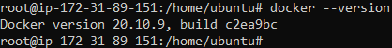

* Also, we will verify that docker is installed correctly by running the hello-world image. It ran successfully.

docker run hello-world

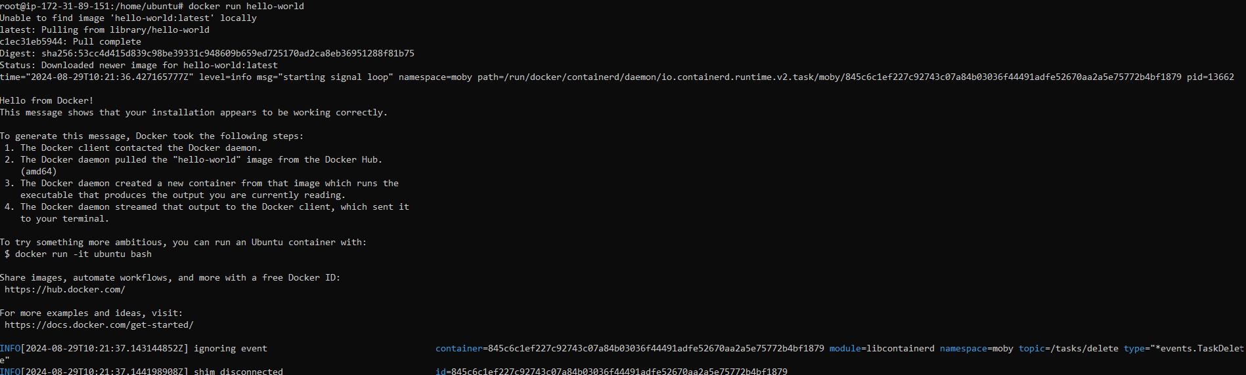

* Verify that the hello-world container got created.

docker ps -a



* Now before upgrading the docker version, we need to kill the dockerd (docker daemon) process id.
* For that we need to find out the process id of docker daemon using the below command.

pidof dockerd



* Now will kill the pid of docker daemon to stop dockerd by using below command.

kill 15615 (process id of dockerd)

On successful execution, we will see the below screenshot.

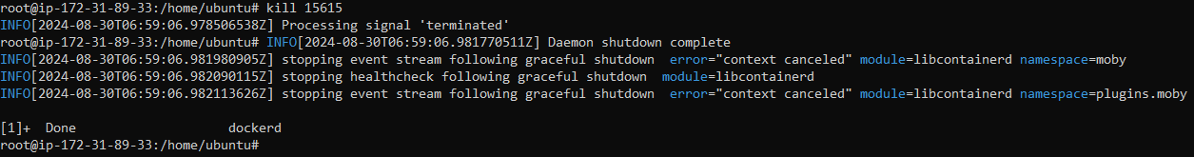

* Now we need to setup the docker repository and then we can install it from that repository.
* Adding Docker's official GPG key using the below commands

apt-get update

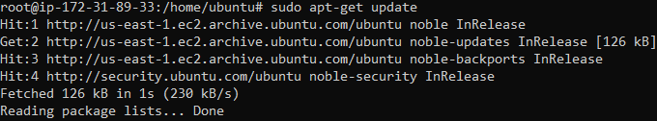

apt-get install ca-certificates curl

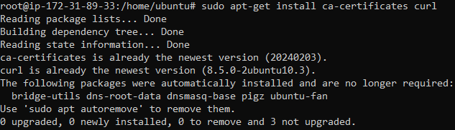

install -m 0755 -d /etc/apt/keyrings



curl -fsSL https://download.docker.com/linux/ubuntu/gpg -o /etc/apt/keyrings/docker.asc



chmod a+r /etc/apt/keyrings/docker.asc



* Now we will add the repository to Apt sources by using the below commands.

echo \

"deb [arch=$(dpkg --print-architecture) signed-by=/etc/apt/keyrings/docker.asc] https://download.docker.com/linux/ubuntu \

$(. /etc/os-release && echo "$VERSION\_CODENAME") stable" | \

sudo tee /etc/apt/sources.list.d/docker.list > /dev/null



apt-get update

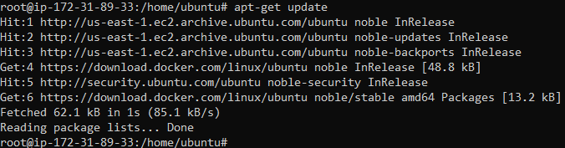

* Now we will install the latest version of docker and components using the below command.

apt-get install docker-ce docker-ce-cli containerd.io docker-buildx-plugin docker-compose-plugin

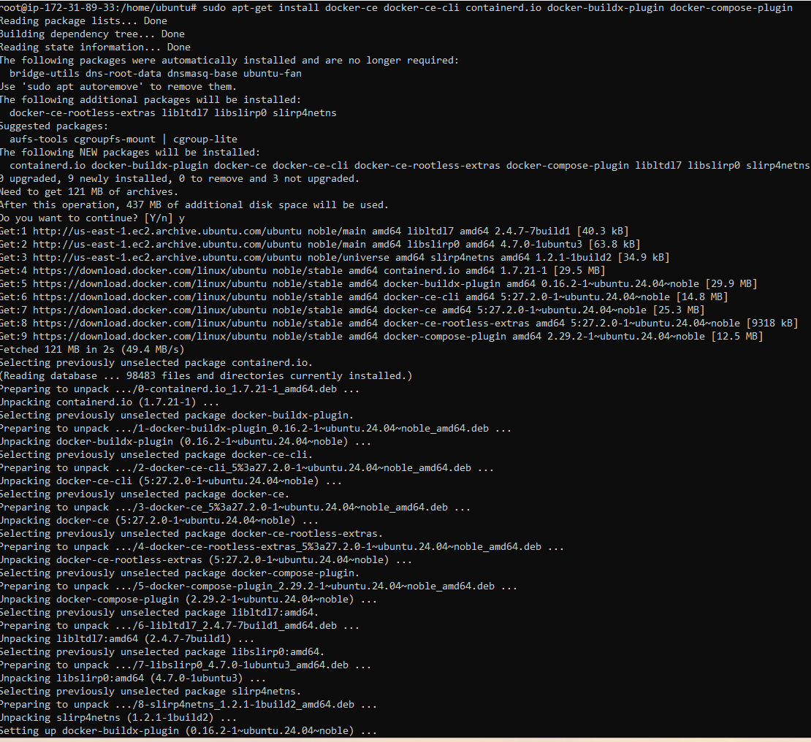

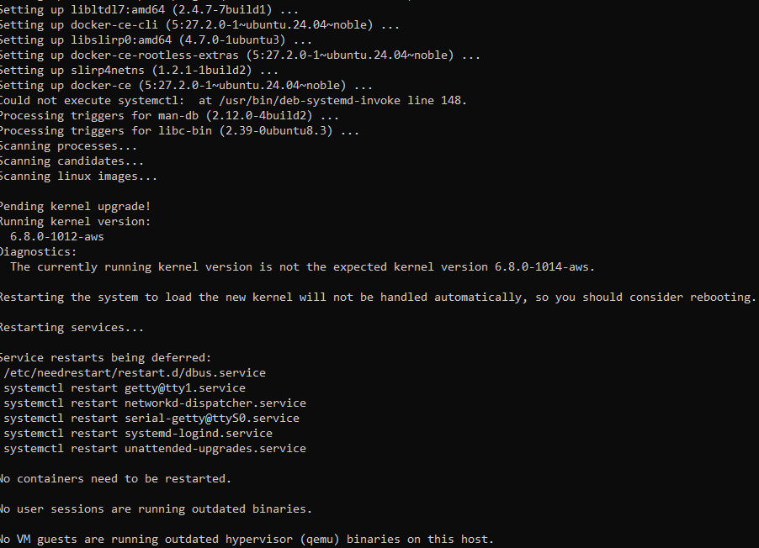

* Now we will restart the docker daemon service by using the below command.

dockerd &

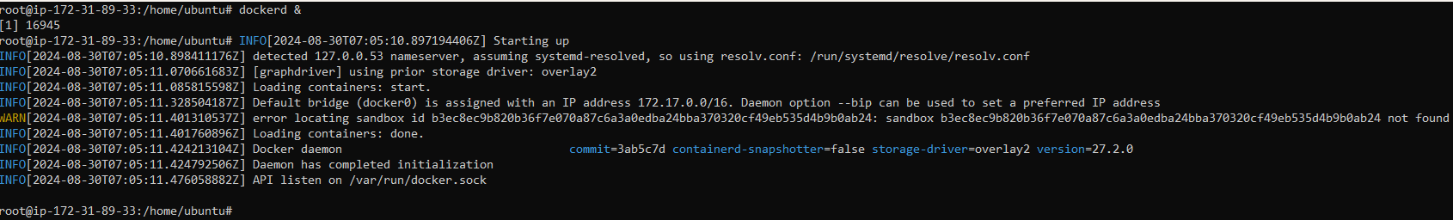

* The docker version is now updated to the latest one.
* We will verify the version by running the below command.

docker --version



* We can see that the image and containers from old and new version are present.

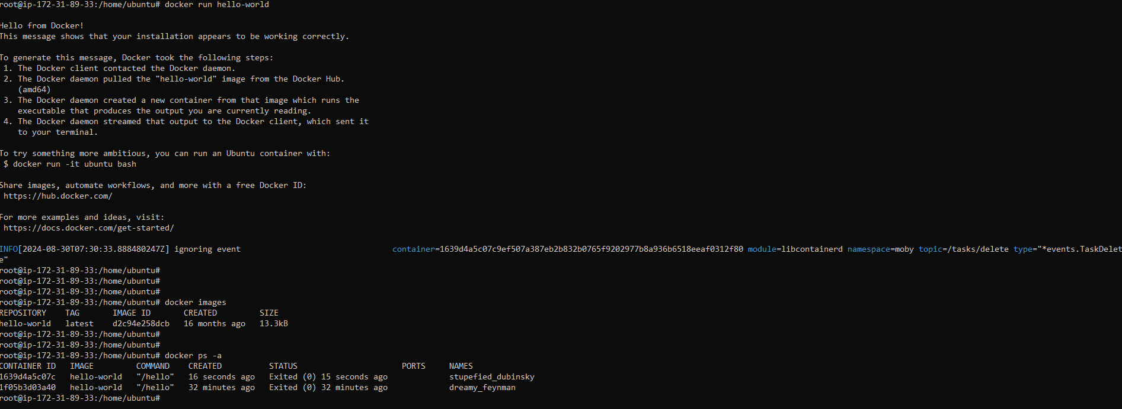

1. **Install Jenkins in docker**

Creating a container with Jenkins installed inside it.

* We will pull the jenkins image from dockerhub.

docker pull jenkins/jenkins:lts-jdk17

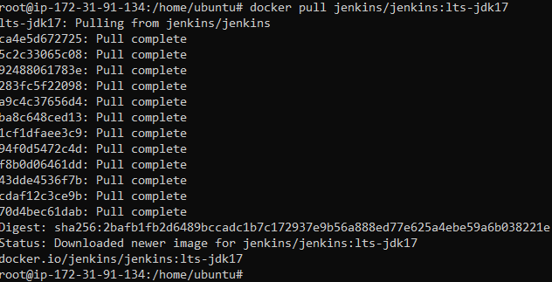

* Verify the image is downloaded.

docker images

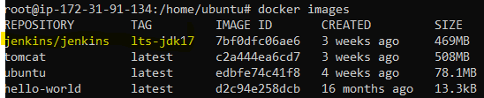

* Now we will Run a container using the image you just pulled.

docker run --name jenkins -p 8080:8080 -p 50000:50000 -v /home/ubuntu:/var/jenkins\_home 7bf0dfc06ae6

**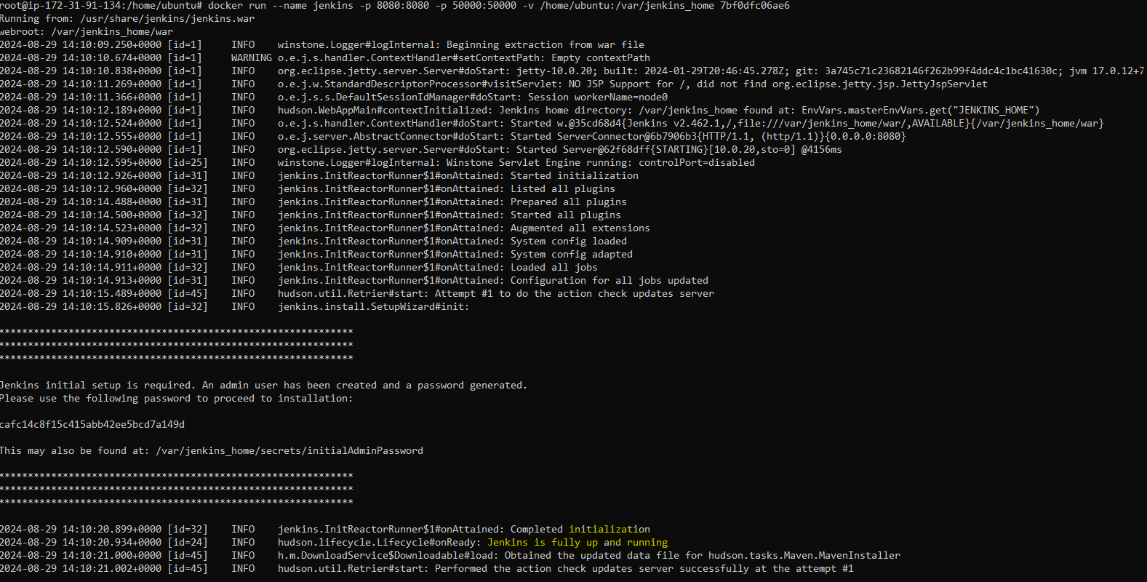**

**docker run:** This is the docker command for starting a container.

**-- name jenkins:** This command will give the container the name jenkins after it has been started.

**-p 8080:8080**: The first 8080 is the port you will use to access the Jenkins service on your own machine(localhost:8080). The second 8080 after the first colon is the Jenkins default port. What we have done with this command is bound port 8080 on Jenkins to port 8080 on our local machine.

**-p 50000:50000:** Same as the case of the Jenkins port above, we are binding the ports to each other. However, in this case, the port is meant for the Jenkins master to be able to communicate with the slaves. The Jenkins master coordinates and does the administrative tasks of your Jenkins infrastructure while the purpose of the slaves is to run the tasks. It is also important to note that the master can also run jobs like the Jenkins slaves. But you can **have** your Jenkins setup without the slaves.

**-v /home/ubuntu:/var/jenkins\_home:** The -v flag is a command for mapping or creating volumes in Jenkins. Data that is generated while a container is running is ephemeral in nature. The image that is used to generate your container is read-only, so any data that is generated while the container is running will exist only inside the container. Once the container is destroyed, all that data is lost. In our case, we do not want to lose all our configurations and settings after our Jenkins container is destroyed. We have to create a volume on our local machine and map it to the Jenkins directory in the container in other to save our data. This way, any files generated while the container is running can still be accessed after the container is destroyed and when we start another container. The first part before the colon(/your/home) is the path on your computer where you want the Jenkins files to be saved.

**7bf0dfc06ae6 -** This last part of our command, specifies the id of the image you want to run, which is the id Jenkins container we just pooled. You can run docker images to get the id of the image pulled on your computer.

* Setup Jenkins

Visit **Public IP of EC2:8080** on your browser. You should see a web page like the one below: If this comes up then we are good

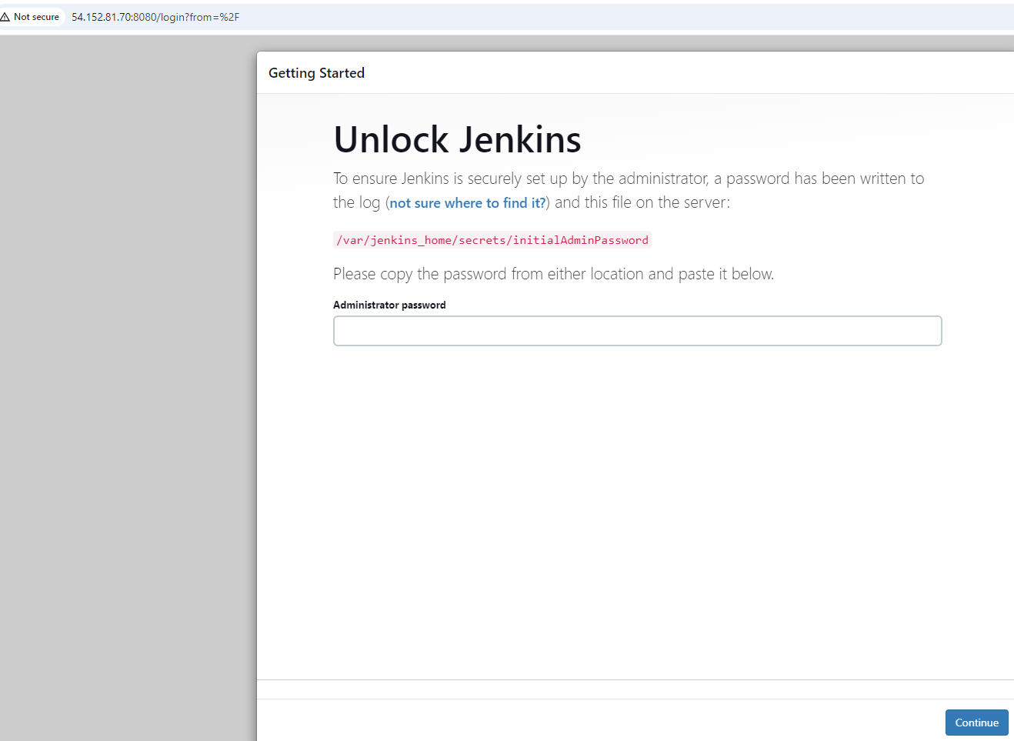

1. **How to copy/move a docker container from one host to another host.**

* The Task is that we need to create a container from the image and create an index file inside it and then save the container and run on different server or EC2 instance.
* For the above tasks, we need to have 2 EC2 instances with docker installed on them, one on which we need to create the container and index file inside it and other EC2 instance is where we will run the saved container copied from first EC2 instance.

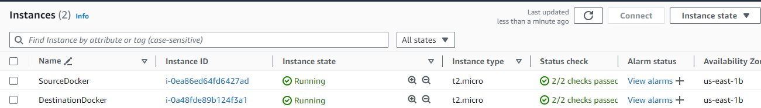

* Now we will perform the task of running a nginx container from nginx latest image in an interactive mode, so that we can create an index.html file on the **SourceDocker** EC2 Instance.
* **SourceDocker**
* We pulled and run a nginx image which created a container by running the below command.

docker run -d -p 80:80 --restart always --name nginxtest nginx

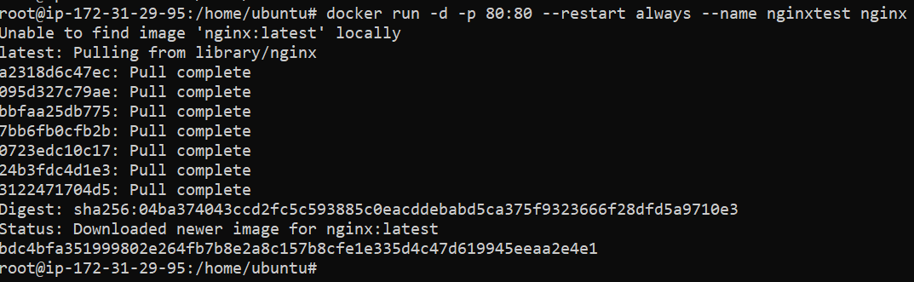

We will verify the container details by running the below command

docker ps

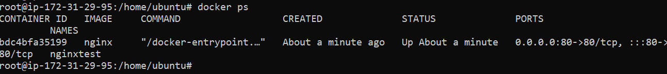

* We checked on Web URL to confirm that nginx was running properly.

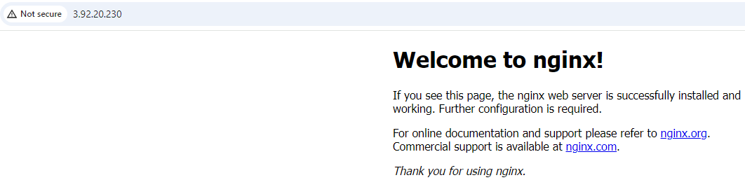

* The nginx container already has default index.html file in it. We will change the content of the index.html and confirm if it’s functioning properly.
* We will run the below command to get inside the running container’s /bin/bash using the container id

docker exec -it bdc4bfa35199 /bin/bash



* Now we will go to the location where the index.html file is kept inside the container.

cd /usr/share/nginx/html

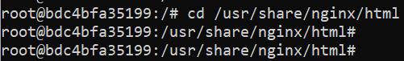

ls -ltr

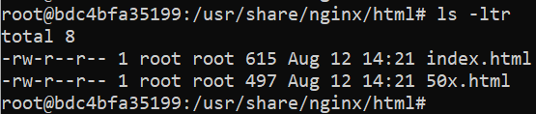

* We will change the content of the index.html from the below command.

sed -i -e 's/nginx!/Sourabh-System/g' index.html



* Now we will test changes on the Web URL. Changes were applied successfully.

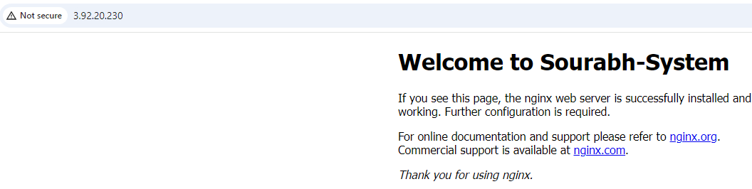

* Now we have our customized index.html file in a running container.
* We will exit out the container and keep it running by using Ctrl p and q
* Now we will stop the container and preserve the current state of the container to a new image.

docker stop bdc4bfa35199 (Stops the container using the container ID)

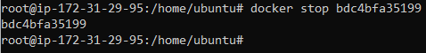

docker commit nginxtest mynginximage (Command preserves the current state of container in a new image)



* Now we will save your newly committed Docker container image to an archive file (tar file) using the below command

docker save -o mynginximage.tar mynginximage (Command saves the committed image to tar file)



Verify the tar image

ls -ltr

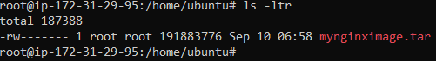

* For this task we need to create test user with home directory and give root level access and setup passwordless ssh as both test account and password less ssh will be used to copy our image using the scp.

sourcedocker

useradd -p abc123 -m test (Command for creating test with unencrypted password using **-p** and creating home directory using **-m**)



We need to reset the password once for the test user to give it an encrypted password. Since, we have setup and unencrypted password using the below command.

passwd test (command to reset the password for the user)

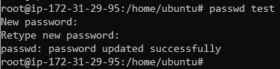

Now we will also verify home directory is created for the test user or not by using the below command.

cd /home/test (Command to change directory)

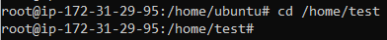

Home directory created and verified

Destinationdocker

useradd -p abc123 -m test (Command for creating test with unencrypted password using **-p** and creating home directory using **-m**)



We need to reset the password once for the test user to give it an encrypted password. Since, we have setup and unencrypted password using the below command.

passwd test (command to reset the password for the user)

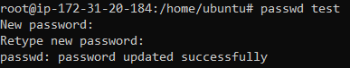

Now we will also verify home directory is created for the test user or not by using the below command.

cd /home/test (Command to change directory)

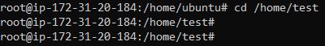

Home directory created and verified

**Providing “test” user root level access with a script which we need to run on all 3 EC2 instances.**

**SourceDocker**

Create a shell script with any name, in my case I created “rootlevel.sh”. Edit the file and enter the below contents in that file.

vi rootlevel.sh (Edit the file)

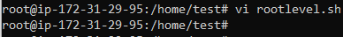

**Contents of the script**

#!/bin/bash

# Uncomment the file to allow password authentication

sed -i '/PasswordAuthentication yes/s/^#//g' /etc/ssh/sshd\_config

# Add below paramaters in the cloud sshd file

echo "PasswordAuthentication yes" > /etc/ssh/sshd\_config.d/60-cloudimg-settings.conf

echo -e "PermitRootLogin yes" >> /etc/ssh/sshd\_config.d/60-cloudimg-settings.conf

# Giving same permissions as root to test

echo "test ALL=(ALL:ALL) ALL" > a.txt

sed -i '47r a.txt' /etc/sudoers

# SSH Service Restart

systemctl restart ssh

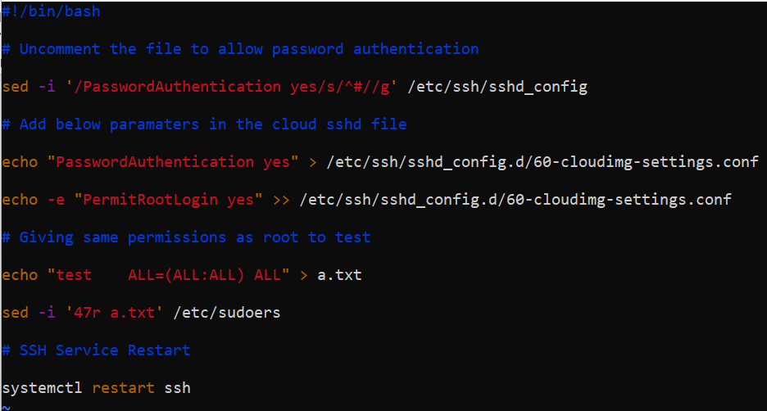

Run the script as bash and test user will have same level of access as root

bash rootlevel.sh



Same steps needed to done on other DestinationDocker.

**Destination Docker**

Create a shell script with any name, in my case I created “rootlevel.sh”. Edit the file and enter the below contents in that file.

vi rootlevel.sh (Edit the file)



**Contents of the script**

#!/bin/bash

# Uncomment the file to allow password authentication

sed -i '/PasswordAuthentication yes/s/^#//g' /etc/ssh/sshd\_config

# Add below paramaters in the cloud sshd file

echo "PasswordAuthentication yes" > /etc/ssh/sshd\_config.d/60-cloudimg-settings.conf

echo -e "PermitRootLogin yes" >> /etc/ssh/sshd\_config.d/60-cloudimg-settings.conf

# Giving same permissions as root to test

echo "test ALL=(ALL:ALL) ALL" > a.txt

sed -i '47r a.txt' /etc/sudoers

# SSH Service Restart

systemctl restart ssh



Run the script as bash and test user will have same level of access as root

bash rootlevel.sh



Now setup password less ssh between master and worker by following below steps.

* **Creating a temporary file “tempUserName.txt” for passing “test” user details on master EC2 instance.**

echo "test" > tempUserName.txt (Command creates tempUserName.txt and puts test as text inside)



* **Creating a file by name “ipaddr” which will contain the Public ip address of destinationdocker on sourcedocker EC2 instance.**

echo "34.234.63.151" > ipaddr (Command creates ipaddr file and puts the ip address as text inside)



* **Setting up password less authentication between master and worker nodes from the master instance using script.**

**SourceDocker**

Create a shell script with any name, in my case I created “passwordless\_ssh.sh”. Edit the file and enter the below contents in that file.

vi passwordless\_ssh.sh (Edit the file)



Contents of the script

#!/bin/bash

# Defining variable for ipaddr file

ipAddFile="./ipaddr"

# Command runs SSH-Keygen without prompting anything

echo -e "\n" | ssh-keygen -N "" &> /dev/null

# Now the Script checks the IP address file and concat the username and IP address to copy the ssh pub key

echo "$ipAddFile"

for IP in `cat $ipAddFile`; do

if [[ $IP == \*"["\* ]]; then

echo "$IP"|cut -d "[" -f2 | cut -d "]" -f1>tempUserName.txt

else

user=$(cat tempUserName.txt)

ssh-copy-id $user@$IP

echo "Key copied to $IP"

fi

done

# Remove tempUserName.txt file

rm -rf tempUserName.txt

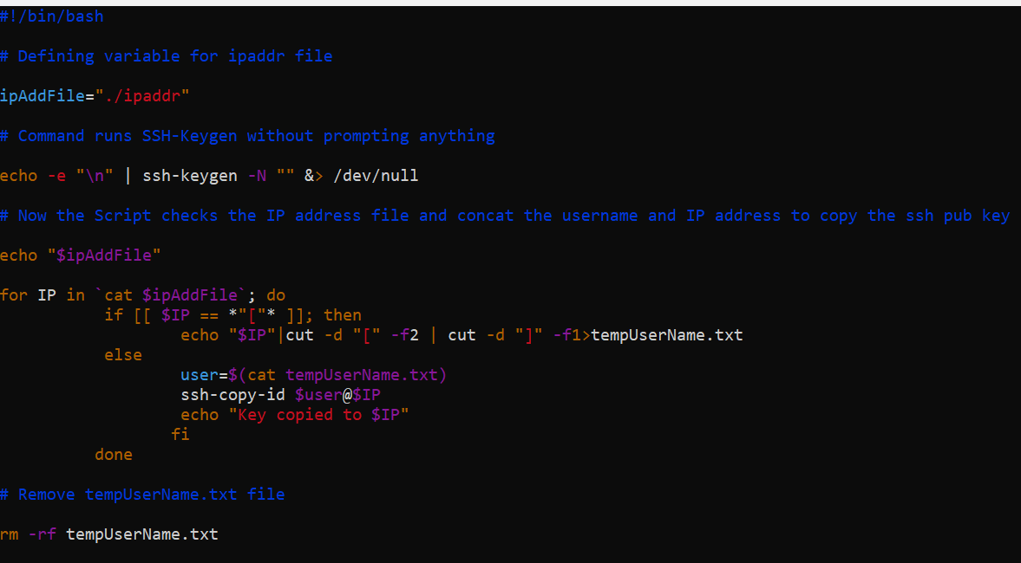

Run the script as bash and passwordless SSH will be setup between source and destination docker.

bash passwordless\_ssh.sh 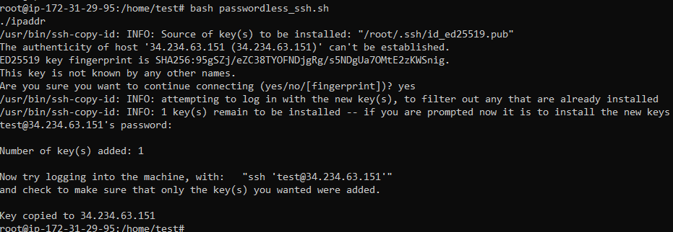

We need to supply password for test user to get the key copied (Above screenshot shows key copied to the IP address in ipaddr file)

* Copy the mynginximage.tar to home directory of test

cp mynginximage.tar /home/test



* Now we will do Scp command to copy our tar file to destination docker.

scp mynginximage.tar [test@34.234.63.151:/home/test/](mailto:test@34.234.63.151:/home/test/)



* Now we will perform the task of running a nginx container from the tar file copied from the **SourceDocker** EC2 Instance on the **DestinationDocker** EC2 instance.
* **DestinationDocker**
* Verify that the myimage.tar file has been copied successfully under /home/test using the below command.

ls -ltr

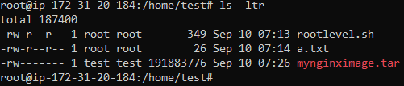

* Now we will load the container image it container on the DestinationDocker EC2 Instance using the below command.

docker load -i .**/**mynginximage.tar

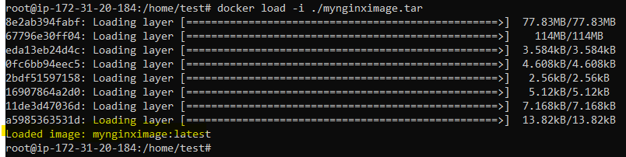

Our saved image is loaded highlighted in the above screenshot.

* We will now reinitialize our Docker container image with its original run flags from your source machine using the below command. For instance, our Nginx Docker container originally had port 80 mapped to my host machine’s port 80

docker create --name my-nginx-container -p 80:80 mynginximage

(Command helps in reinitialize our Docker container image with its original run flags from your source machine)



* We will run the newly imported docker container using the below command.

docker start my-nginx-container

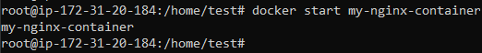

To verify, we will run

docker ps -a



* Now we will test the Web URL to see if the index.html file shows the same content as shown the SourceDocker EC2 instance

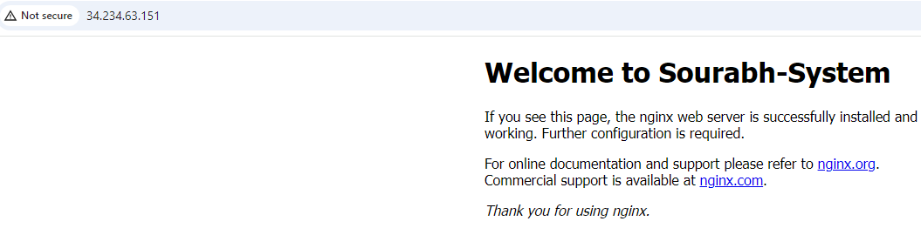

* We can see it has loaded the same contents as it displayed in source EC2 instance.
* Task has been completed to Copy/Move a Docker Container to Another Host.

1. **Create your own local docker registry and put an image with your created tag on it.**

* To create our own docker registry we need to pull and run a registry image and create your own docker registry locally on the ec2 instance. Below command is used for the same

docker run -d -p 5000:5000 --restart always --name sourabh0905 registry

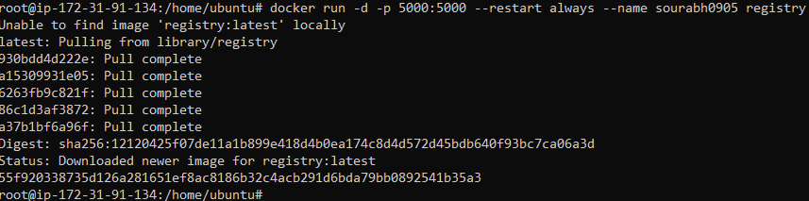

Check if the registry is created

docker ps -a



check if registry is accessible via URL

<http://44.204.229.111:5000/v2/_catalog>

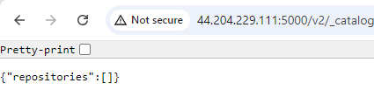

* Now we will pull an image from docker hub (ubuntu:latest)

docker pull ubuntu:latest

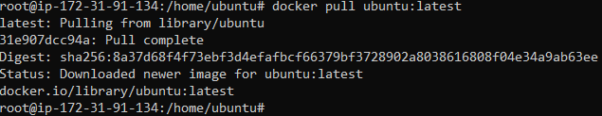

Verify the image has been downloaded

docker images

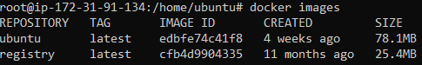

* We will tag the image to point to your local registry by using below command

docker tag ubuntu:latest 44.204.229.111 (public IP of EC2):5000/ubuntu:latest



Verify the image has been tagged

docker images

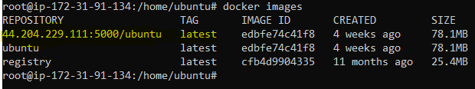

* Now before pushing the image to our local registry. We need to add our Public IP:5000 to the insecure registries on the ec2 instance.
* We can view the insecure registries by using the below command

docker info

Before adding our Public IP and port to insecure registries.

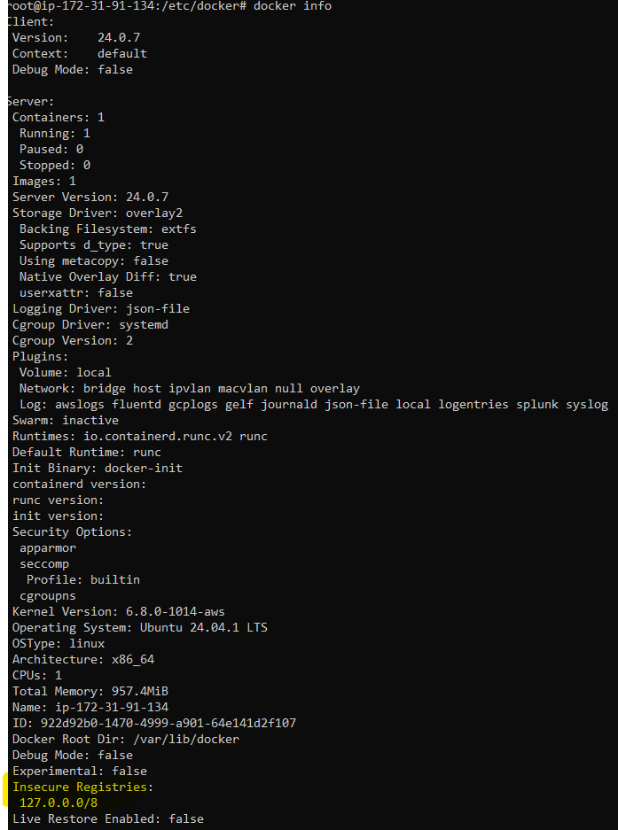

* To add our Public IP:5000 to the insecure registries on the ec2 instance, we need to create file called daemon.json under the /etc/docker

cd /etc/docker



vi daemon.json



add the lines below in the daemon.json file

{ "insecure-registries":["host:port"] }

In our case.

{ "insecure-registries":["22.204.229.111:5000"] }

Esc wq!

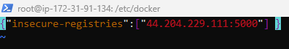

* Need to restart docker service after creating the daemon.json file. So that changes can take effect.

systemctl restart docker



* Now we will verify that our entry is reflecting or not by running again

docker info

After adding our Public IP and port to insecure registries.

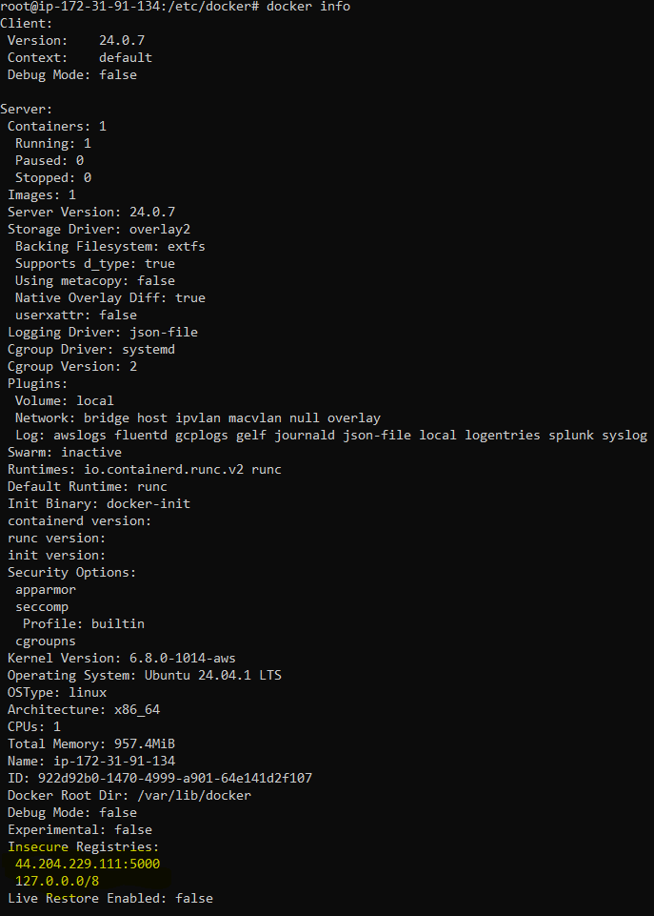

* Now we will push the image to our local registry running the below command.

docker push 44.204.229.111 (public IP of EC2):5000/ubuntu:latest

We can see that our tagged image has been pushed to the local registry.



* Now we will verify that image is there on our local registry by running below command and going to the image location in the registry.

docker exec -it sourabh0905 (registry name) sh

-it (refers to interactive and tty stdin and stout)

sh (shell)

We can see the image located in the local registry.

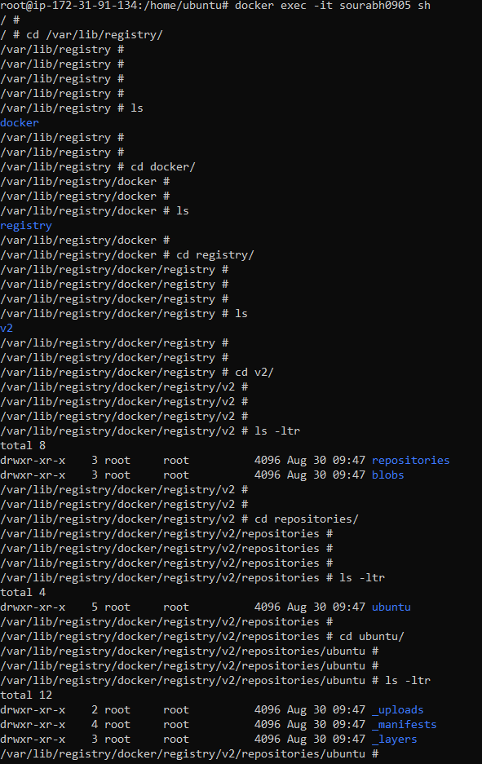

1. **Push an image on Docker Hub repository. (Need to pull image, then create a tag on it and then push it back to docker)**

* Before pulling the image on the ec2 instance, we need to have a dockerhub account and there we need to create a public repository.

In my case, below are my details for dockerhub and public repository created on it.

sourabh1023 – username for dockerhub

sourabh0989 – public repository on docker hub

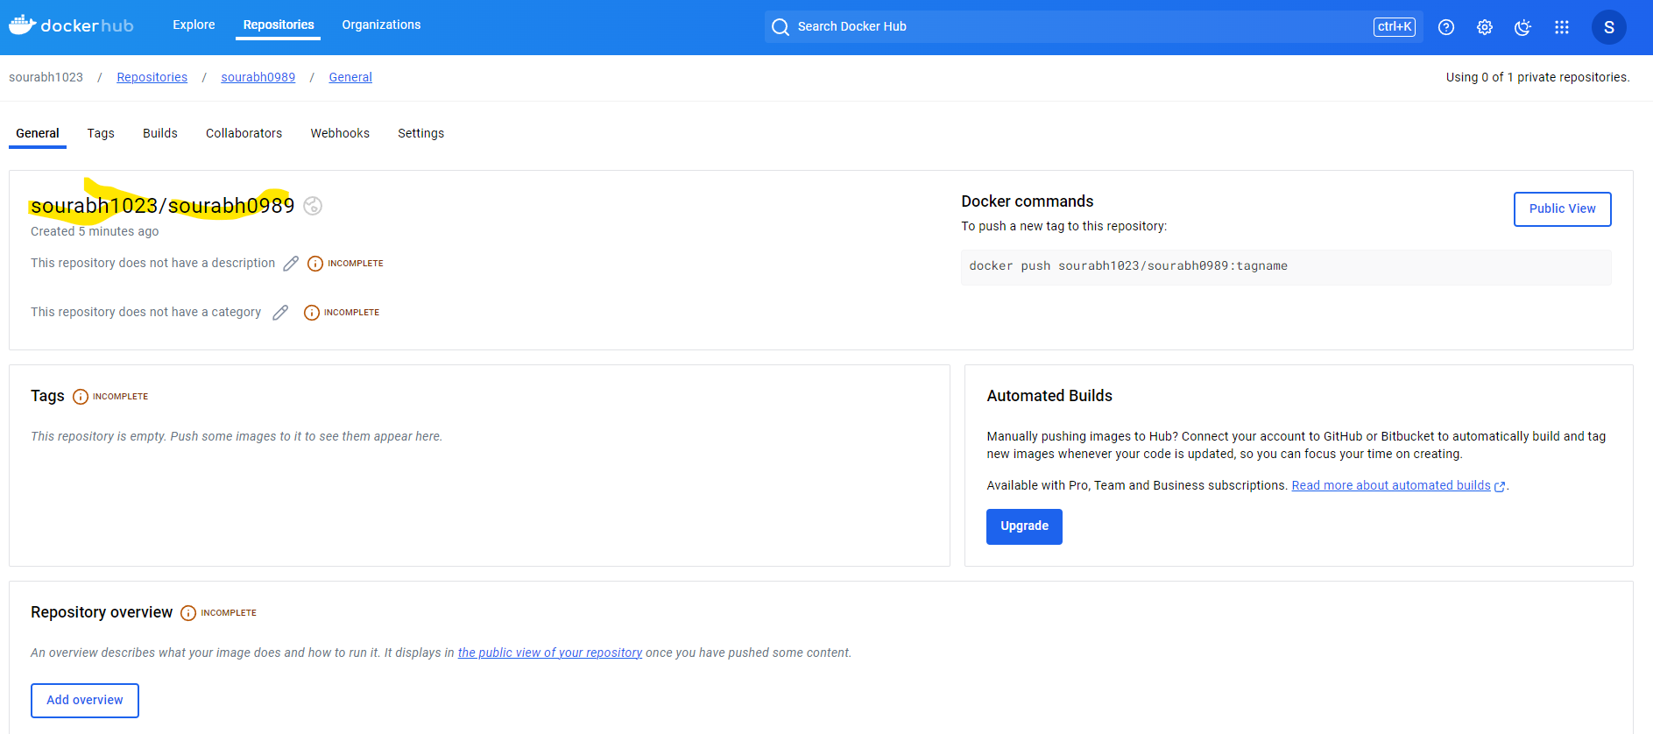

* Now we will pull an image from docker hub (ubuntu:latest)

docker pull ubuntu:latest



Verify the image has been downloaded

docker images

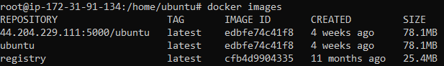

* We will tag the image to point to our public repository on docker hub by using below command.

docker tag ubuntu:latest sourabh1023/sourabh0989:v1



Verify the image has been tagged properly with our docker hub public repository.

docker images

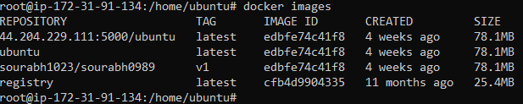

* Since its our own public repository, So to push an image, we need to enter credentials of our docker hub.

For password, we need to generate a token from our dockerhub by following the below steps

On your docker hub, Go to Account Settings

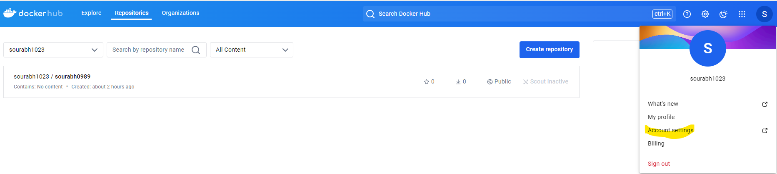

Under Account Settings > Personal access tokens

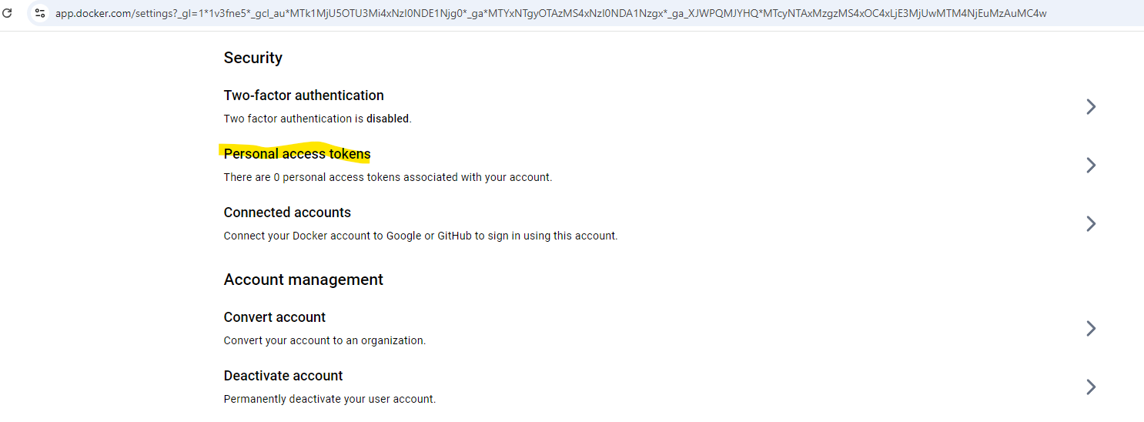

There will be new access token creation request.

Fill the token details

Under access and permissions select **Read & Write**

click generate

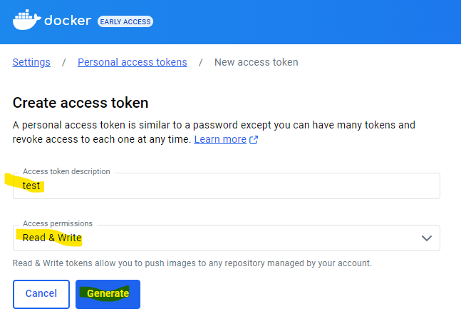

You will get the below screen with token details. Copy them on ec2 instance to enter the public repository.

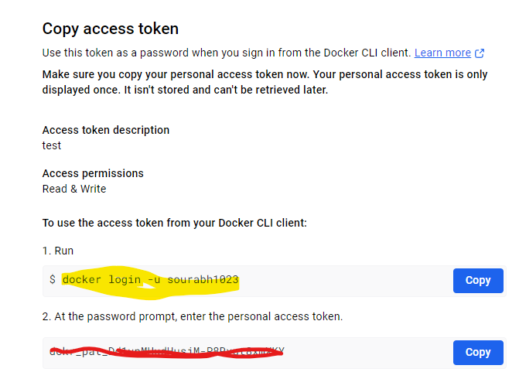

* Now we will proceed with docker login by using the commands in the above screenshot.

docker login -u sourabh1023



Password:

Copy and enter the token

Login succeeded

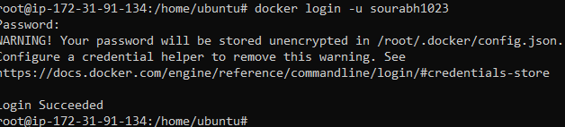

* Now we will push the tagged image on our public repository using the below command.

docker push sourabh1023/sourabh0989:v1

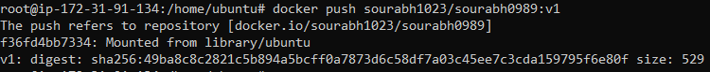

* We will now verify that the image is pushed on our repository. Below screenshot confirms the same.

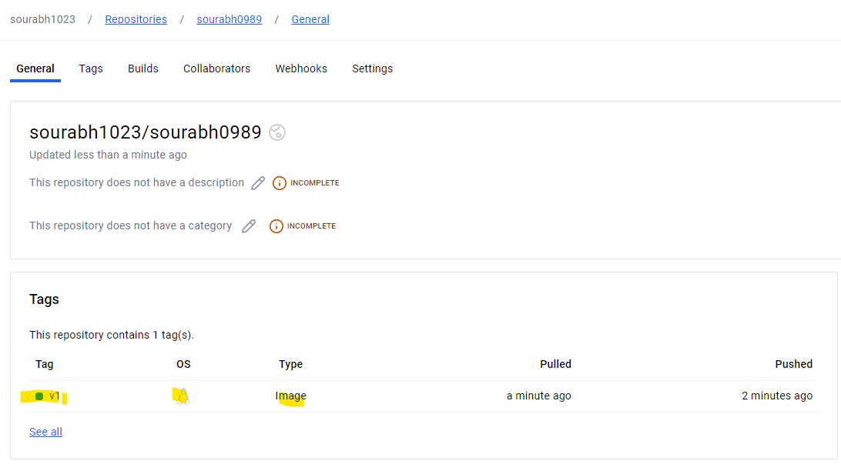

1. **Unused Objects or Dangling Images**

Images are hanging around and it does not have a proper tag or name right now. (You can check the image ids to see that this is the same image we built previously).

Docker calls such images dangling images.

Example:

* We will create a docker file with the below entry.

vi dockerfile



FROM ubuntu:latest

CMD ["echo", "Hello World"]

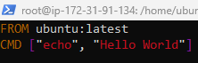

* We will build an image from the dockerfile using the below command

docker build -t my-image .

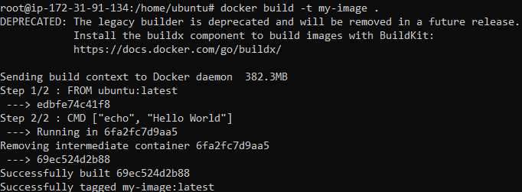

We will verify whether our image is created.

docker images

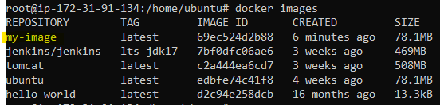

* Now we will edit the same docker file and make some changes.

vi dockerfile



FROM ubuntu:latest

CMD ["echo", "Hello, World!"]

* Now we will create image from the same dockerfile but will not give it any name this time by using the below command

docker build . [. Signifies docker file is in current folder]

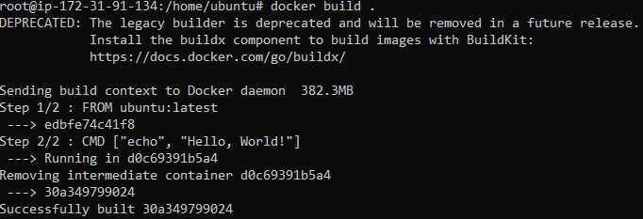

We will verify whether our image is created.

docker images

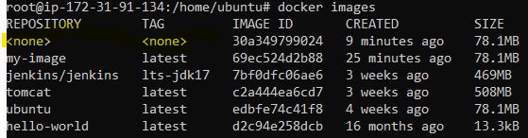

This image which is created with <none> <none> is called a dangling image

* We can use the following command to list dangling images:

docker images --filter "dangling=true"

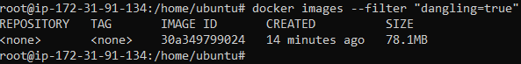

* We can use the following command to delete the dangling images:

docker rmi $(docker images -q --filter "dangling=true")



We will verify whether the dangling image is removed or not.

docker images

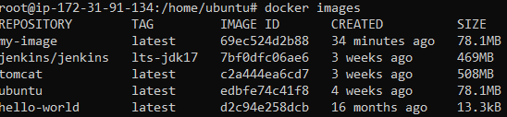

The image which is created with <none> <none> is deleted now.

1. **Create Docker Swarm with 3 workers and shutdown the master and see if leader is relected or not.**

* To perform the activity, we need at least, 4 EC2 instances with docker installed on them, we will create 1 Master or Leader (Manager) and other will be workers in the docker swarm. We have defined the hostname to avoid any confusion.

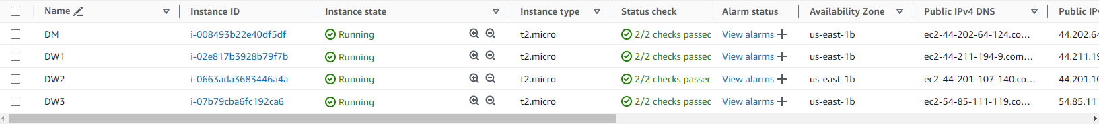

* Now setup password less ssh between master and worker by

following below steps.

On master: Type **ssh-keygen** and follow all steps as follows to

generate public key and private key

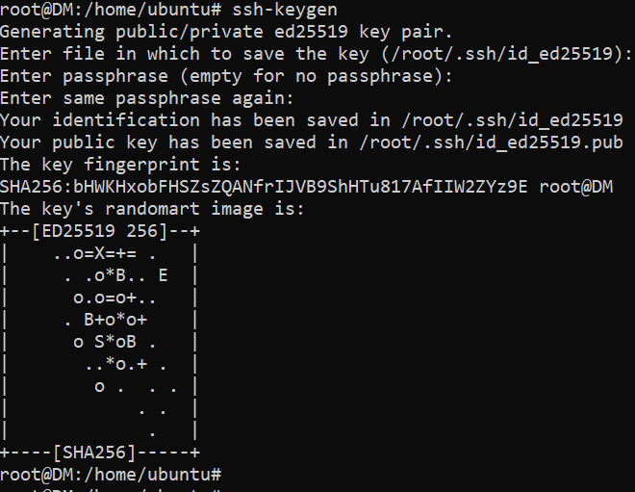

Now do **cat /root/.ssh/id\_ed25519.pub** and copy all the contents

inside it.



On all Workers: Do **cat >> authorized\_keys** (append authorized\_keys

file and paste the contents copied from master server)







Now we will ssh to all worker nodes from master using the Public IP

Address.

Worker Node 1

ssh PublicIP



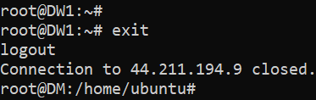

Worker Node 2

ssh PublicIP



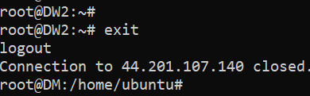

Worker Node 3

ssh PublicIP



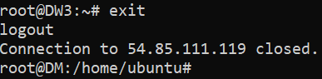

All three worker nodes have been verified

* Run the below command to master node to make it manager IP

docker swarm init --advertise-addr (Public IP of Master Node)

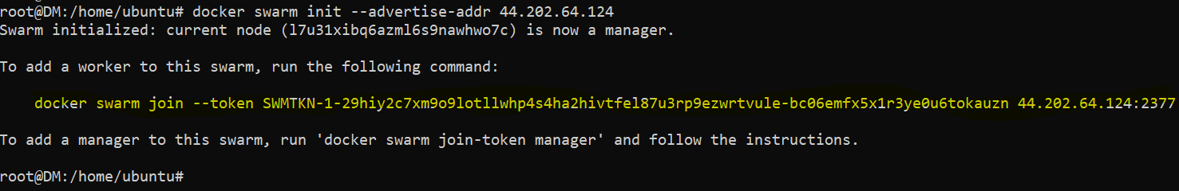

* Now run the next command highlighted the above screenshot on all

the worker nodes so that worker nodes join swarm as worker.

Command differs scenario to scenario as token will be different in

different cases.

DW1



DW2



DW3



* To verify whether the node is joined as worker, we will run the

below command from master.

docker node ls

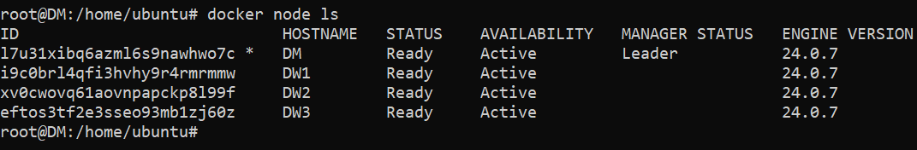

* Now we stop the EC2 instance DM, which is currently showing as the Leader node, so see if the re-election happens automatically or not.



* If we run docker node ls on any of the worker nodes e.g. on DW1, it gives the error as in the below screenshot.

DW1

docker node ls



[Error response from daemon: This node is not a swarm manager. Worker nodes can't be used to view or modify cluster state. Please run this command on a manager node or promote the current node to a manager.]

The same result comes even if we run the command on other worker nodes DW2 and DW3

* This shows that the manager/leader re-election does not happens automatically. In order to get the new manager/leader, we need promote any one of worker nodes to be the new manager.

1. **Docker Uninstallation**

* To remove/ Uninstall docker completely we will follow the below sub steps.
* Removing Docker Images, Containers, Volumes, and Configurations.

Run the below command to remove running docker containers by first stopping them and later removing them

docker stop $(docker ps -a -q) (Stops all Running Containers)

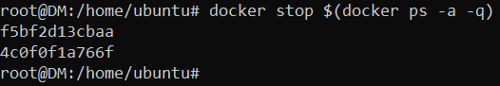

To verify, we run

docker ps -a



docker rm $(docker ps -a -q) (Removes all the containers)

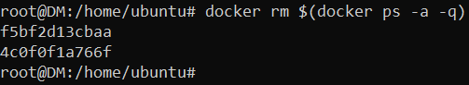

To verify, we run

docker ps -a



Now we will remove the docker images

Before Running the below command, run below command to see the images present.

docker images

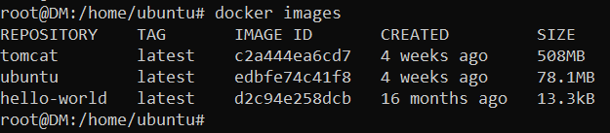

Run the below command to remove the docker images

docker rmi $(docker images -a -q) (Removes all docker images)

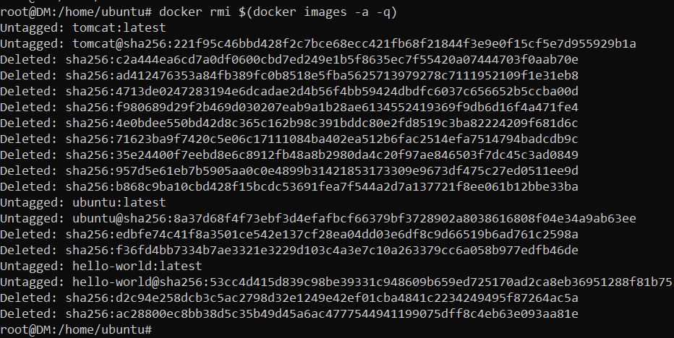

To verify, we run

docker images

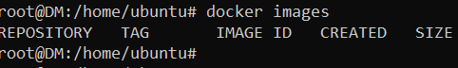

Remove all docker networks

docker network prune (Remove all docker networks)

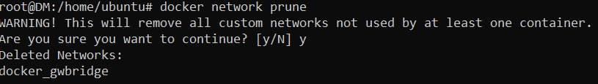

Below command cleans up unused Docker components, freeing space but also potentially resulting in data loss.

docker system prune -a

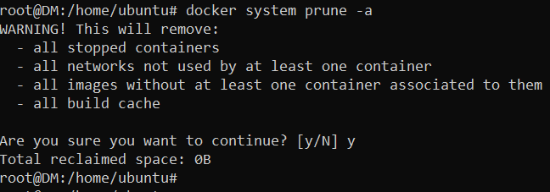

The command docker system prune -a is a powerful tool that removes:

* All stopped containers
* All networks not used by at least one container
* All volumes not used by at least one container
* All images without at least one container associated with them
* All build cache
* Delete Docker Packages

Below command lists out the docker packages on our system

dpkg -l | grep -i docker (lists out the docker packages on our system)



In our case, we only have docker.io

Upon identifying the docker packages, now go ahead and delete them using the below command

apt-get purge docker.io (deletes the docker packages installed on our system

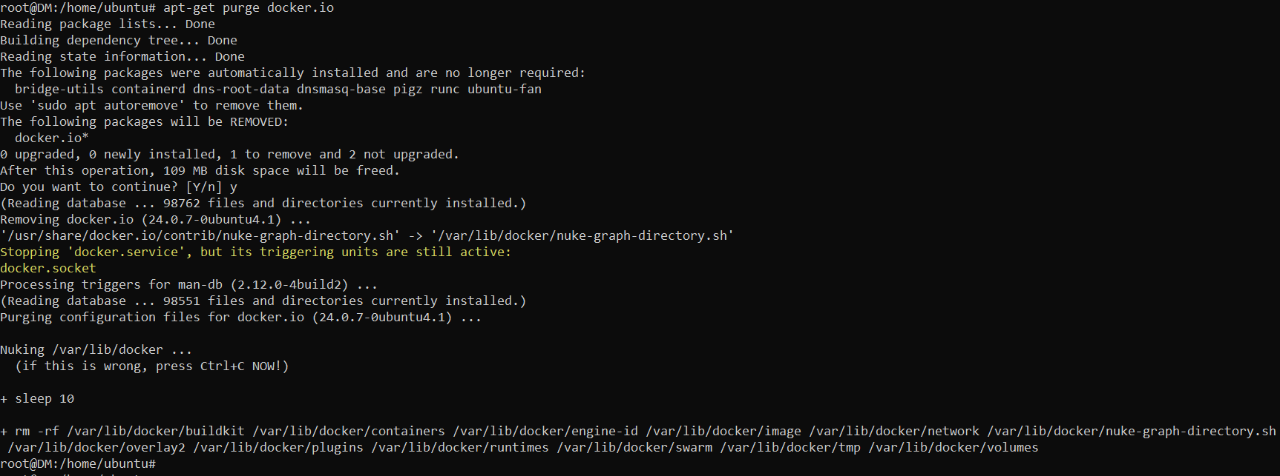

* Deleting the remaining docker files

We need execute the commands to completely remove docker and its related files from your system.

All the docker files will be in the /var/lib/docker path so you have to remove the folder.

rm -rf /var/lib/docker /etc/docker (Removes all files and directories from both the path)



Delete the docker group that you have created in order to run the docker as non-root user or without [sudo](https://www.golinuxcloud.com/sudo-command-in-linux/" \o "10+ sudo command examples in Linux [Cheat Sheet]" \t "_blank)

groupdel docker (Removes the group)

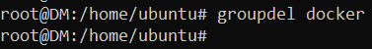

Delete the docker socket using the command below

rm -rf /var/run/docker.sock (Removes the docker.sock)



With this, the uninstallation of docker will be successful. You can verify if the docker has been uninstalled by typing docker command. Upon successful uninstallation of docker, you will see the below output.

docker

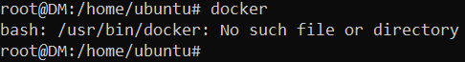

* Cleanup unused packages

This command removes packages that were installed as dependencies and are no longer used and that's it, you have successfully removed docker from your system

apt-get autoremove (Removes all dependencies that are no longer used)

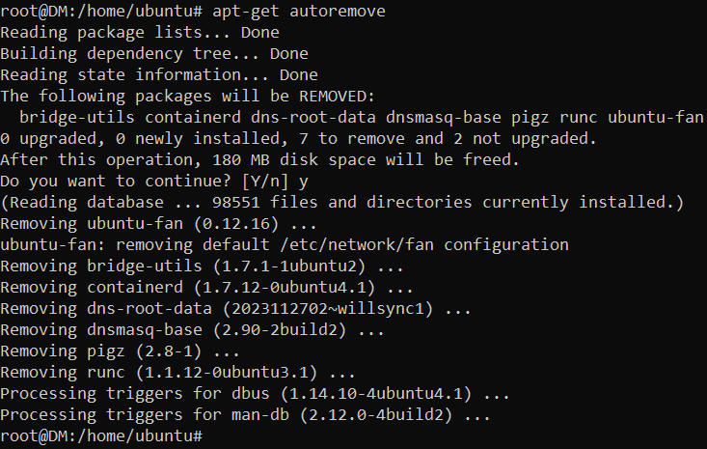

* Docker has been successfully uninstalled and removed from the system.

1. **Docker installs without internet**

* There are multiple ways where we can install docker without internet access to the EC2 instance.
* One of the methods in AWS is to setup your own VPC, define public subnet with internet gateway attached and private subnet with NAT Gateway attached so that, EC2 connected to private subnet or network can download docker through NAT Gateway.
* Steps to perform the above are as follows.
* Create your own VPC with a network range 10.0.0.0/16

In AWS console, search for VPC and click on it.

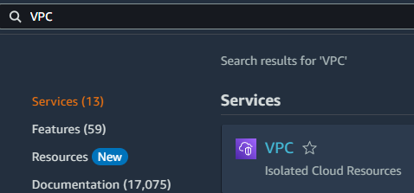

Then click Create VPC

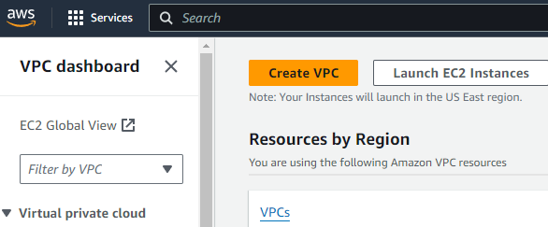

Under Create VPC, select the below settings and provide a name for your VPC with cidr range 10.0.0.0/16. In our case, myvpc is the name of our VPC, then click create VPC.

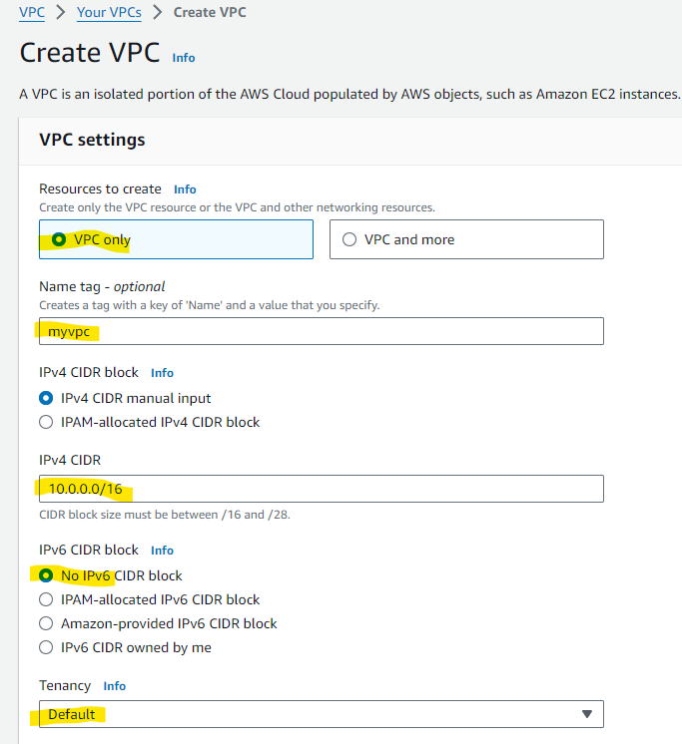

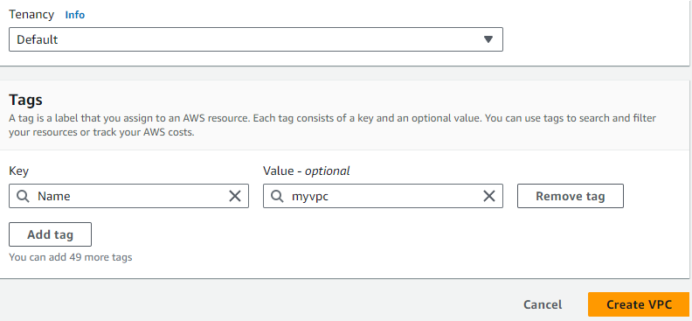

VPC is successfully created.

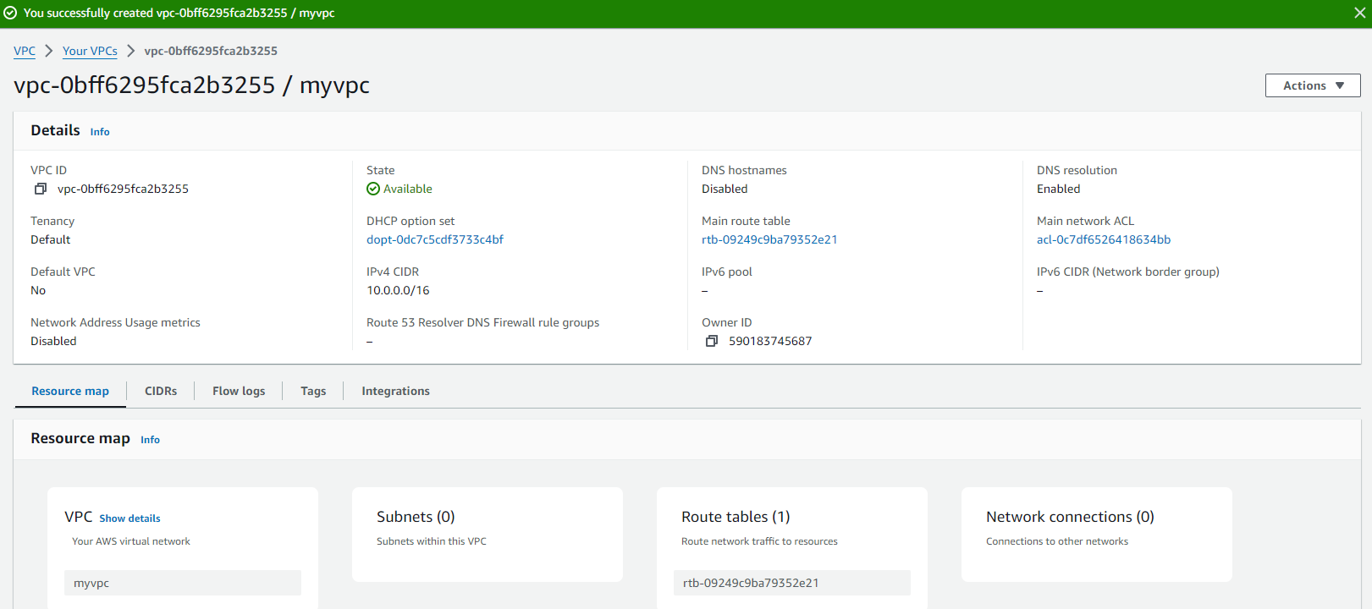

* Now we will go to Route Tables under VPC dashboard.

We will see there is Route table created with our VPC

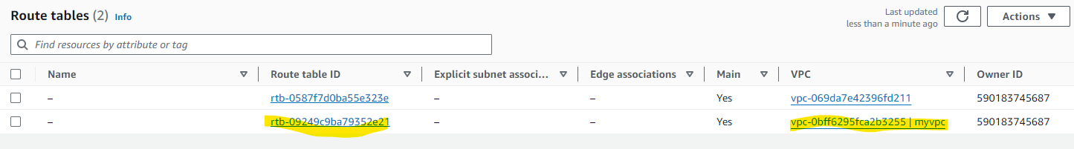

We will rename it as mypubrt (my public route table)

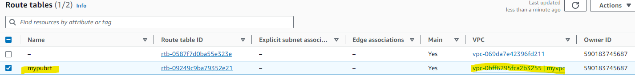

* Now we will go to subnets under VPC dashboard.

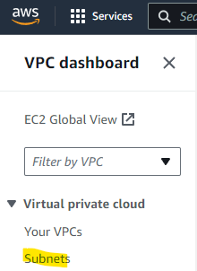

Click Create Subnet



We will create a public subnet, attach it to the VPC we created and give it a name mypubs (my public subnet) and give it a cidr range 10.0.0.0/24 and click create subnet

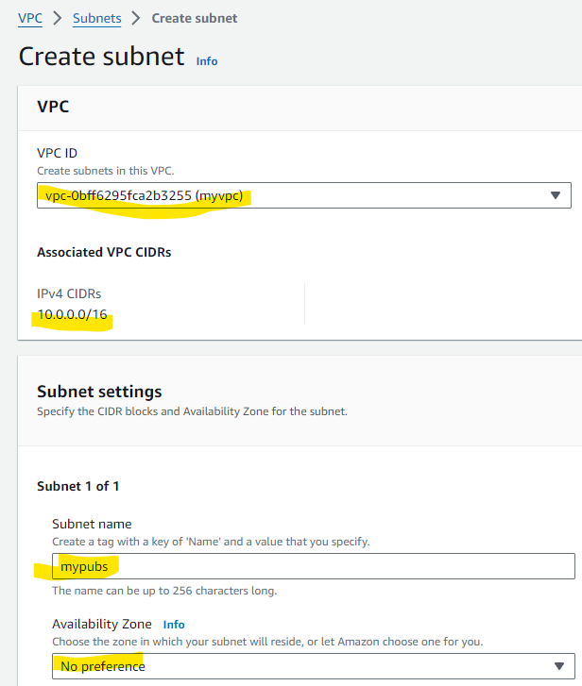

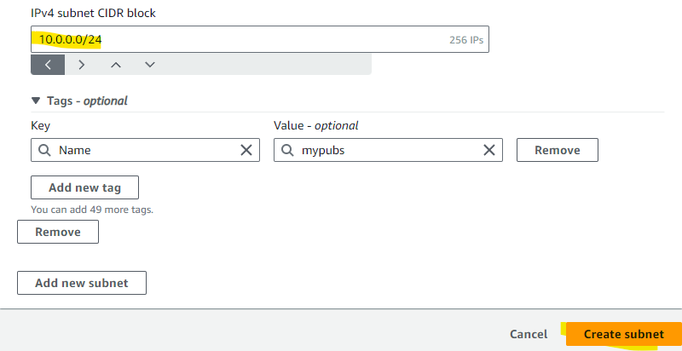

Public Subnet created successfully

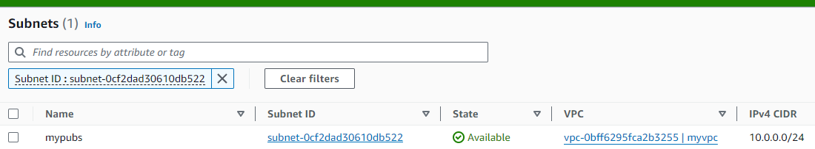

* Now again we will go to Route tables and under our Public Route Table (mypubrt) > subnet associations > Edit subnet associations

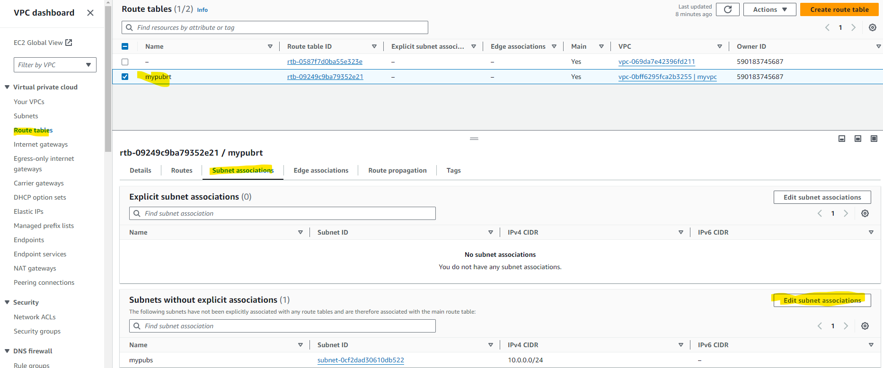

Click mypubs subnet and save associations.

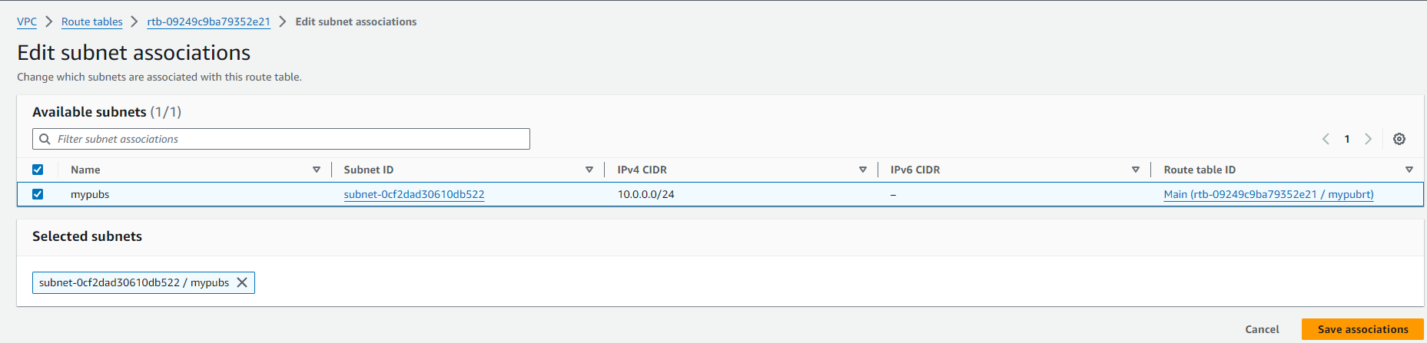

* Now we will go to Internet gateway under VPC dashboard.

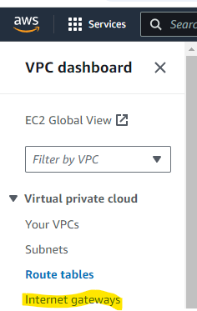

Click Create internet gateway.



We will create an internet gateway, attach it to the VPC we created and give it a name myigw (my internet gateway) and click create internet gateway.

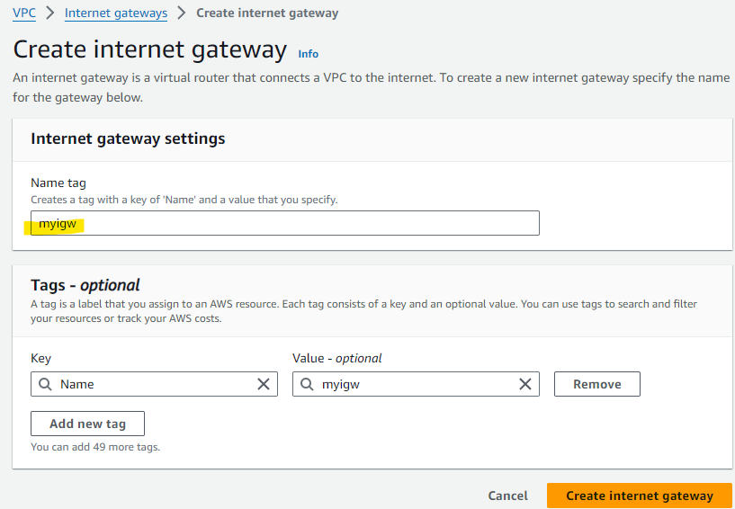

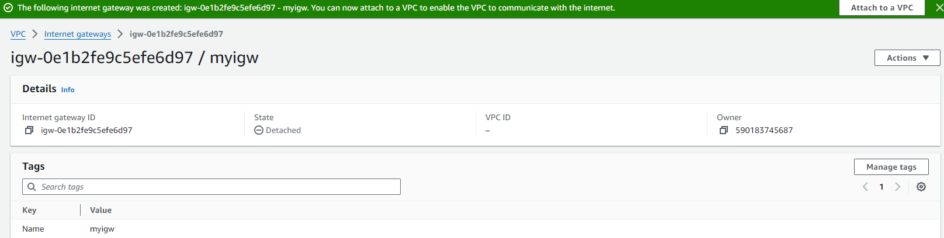

Now we attach the internet gateway to our VPC by clicking on Attach to VPC in the below screenshot.

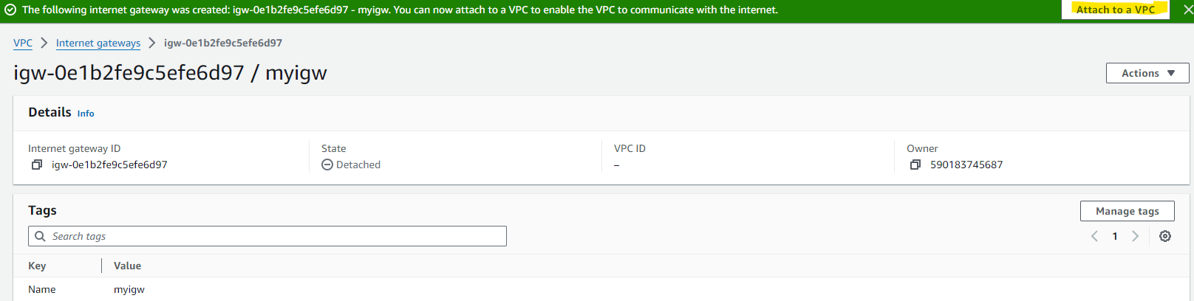

Select our VPC from the drop-down list and click attach internet gateway.

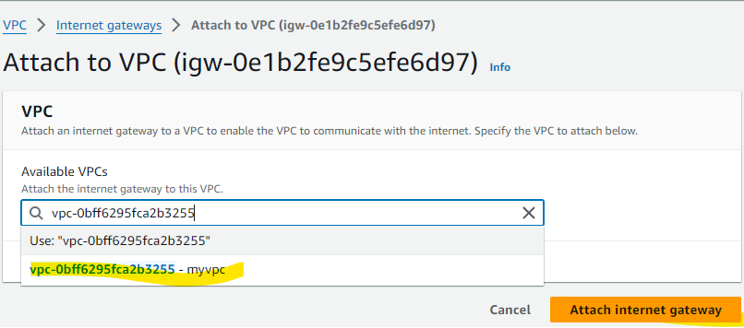

VPC attached successfully

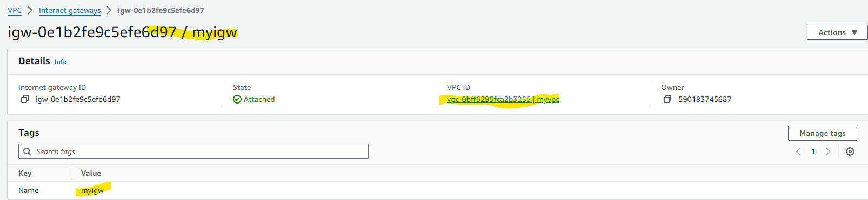

* Now again we will go to Route tables and under our Public Route Table (mypubrt) > Routes > Edit Routes

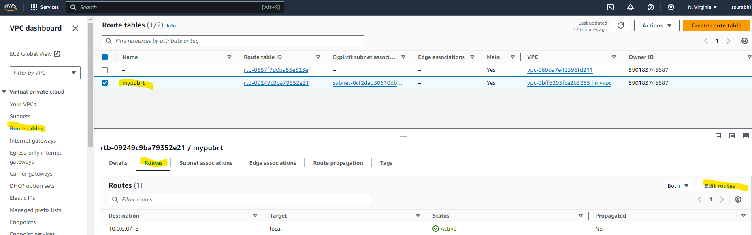

Click on Add Route

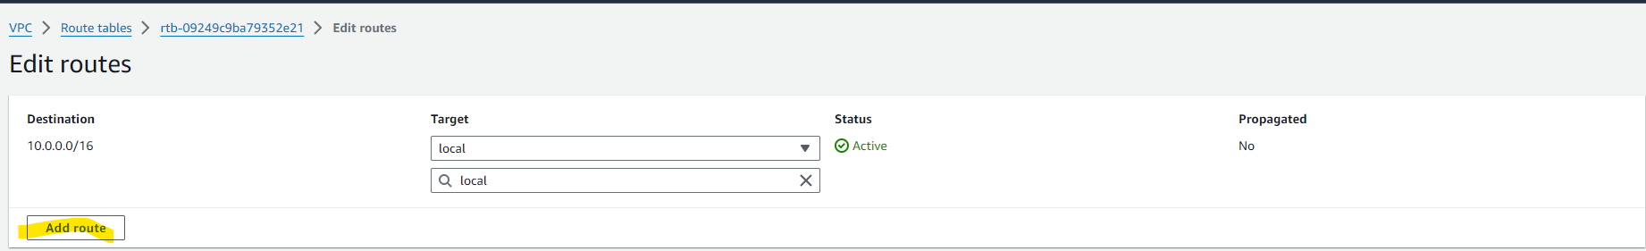

Under Destination we will give 0.0.0.0/0 and under target we will give internet gateway and attach the internet gateway (myigw) that we created and click save changes.

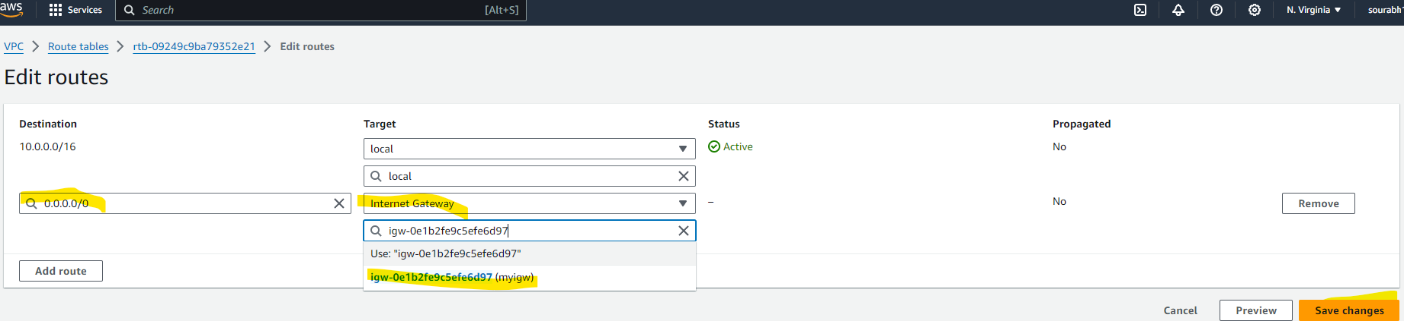

* Now we will go to subnets under VPC dashboard.



Click Create Subnet



We will create a private subnet, attach it to the VPC we created and give it a name myprvs (my private subnet) and give it a cidr range 10.0.1.0/24 and click create subnet

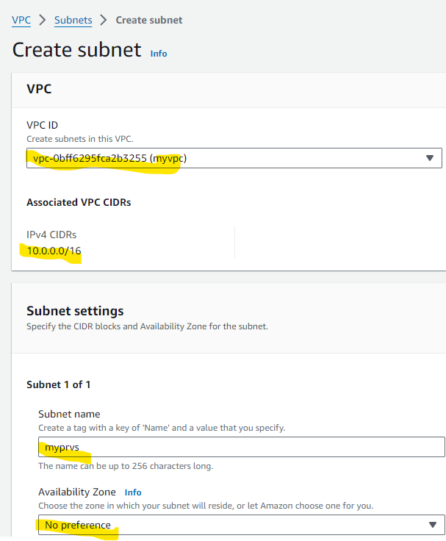

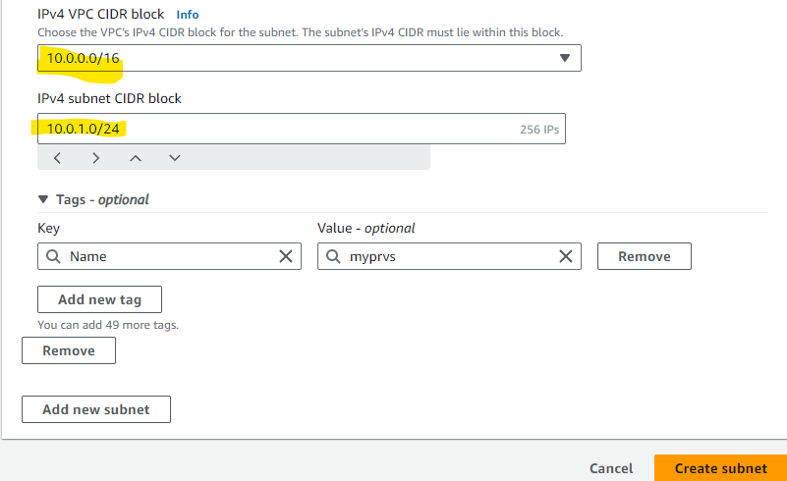

Private Subnet created successfully.

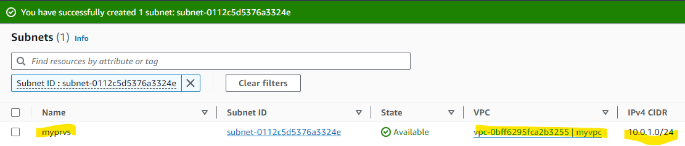

* Now again we will go to Route tables and click create route table.



Under create route table we will give the name as myprvrt (my private route table). Attach the VPC we created to it and click create route table.

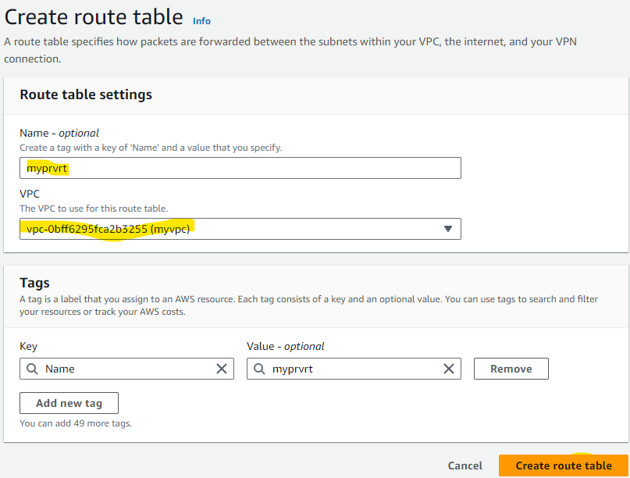

Private route table created successfully.

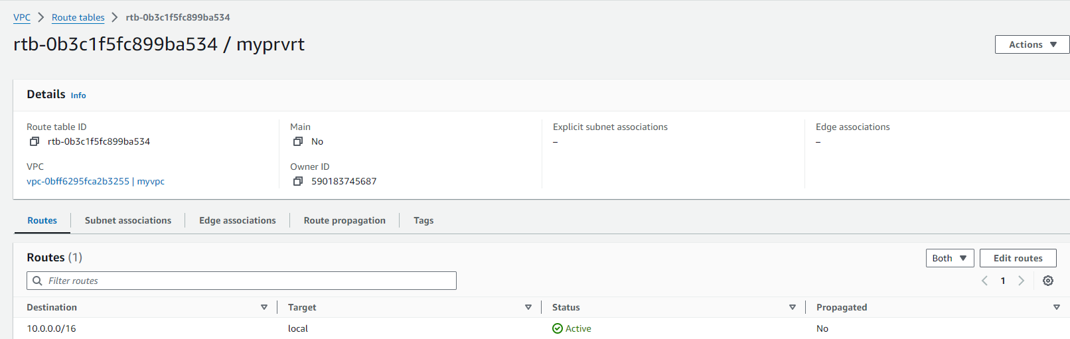

* Now again we will go to Route tables and under our Private Route Table (myprvrt) > subnet associations > Edit subnet associations.

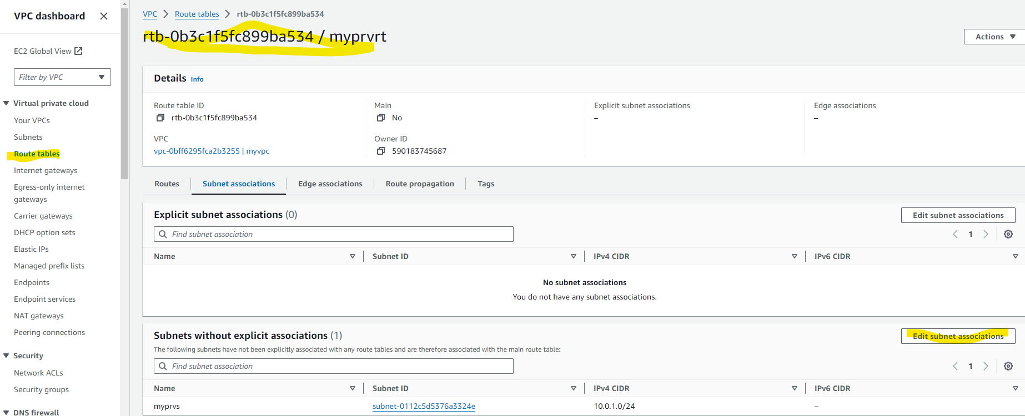

Click myprvs subnet and save associations.

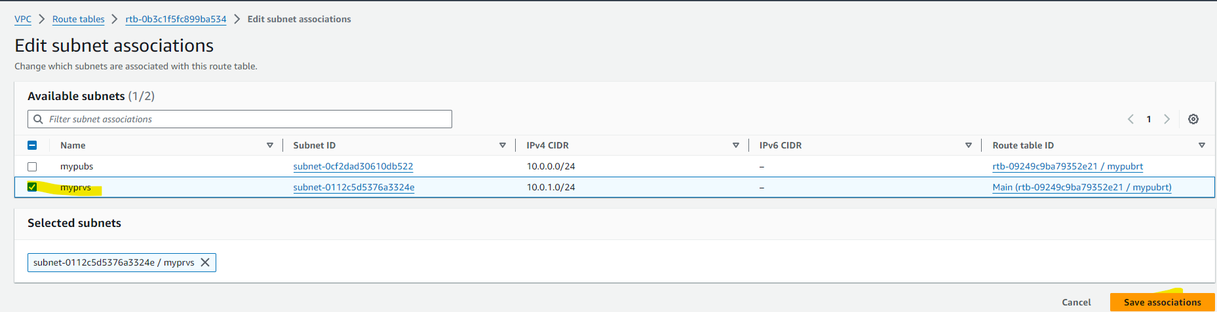

* Now we will create an EC2 instance on our VPC (myvpc) under public subnet (mypubs) along with new security group name mypubsg, where we will allow SSH and HTTPS port on the inbound rules, so that we can check the internet connectivity is working on the it or not.

In AWS console, search for EC2 and click on it.

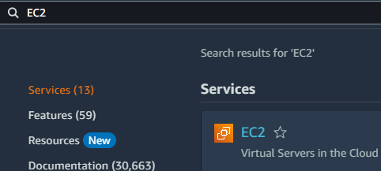

Launch an instance

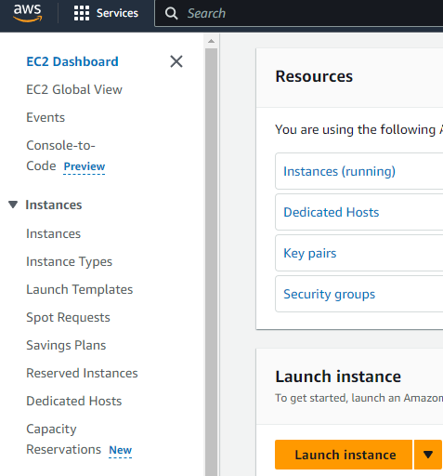

Now fill in the details with name as mypubm (my public machine), select OS as ubuntu

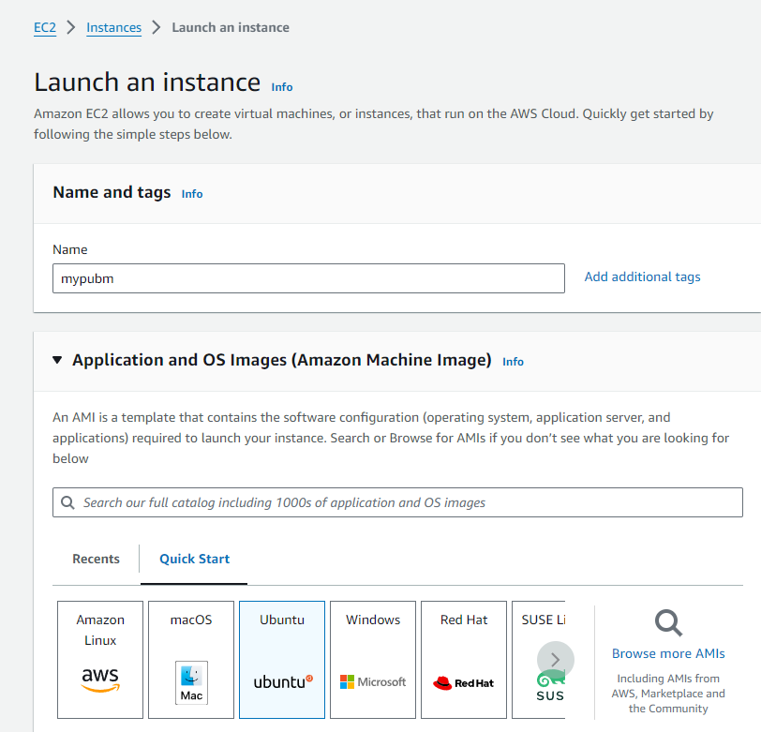

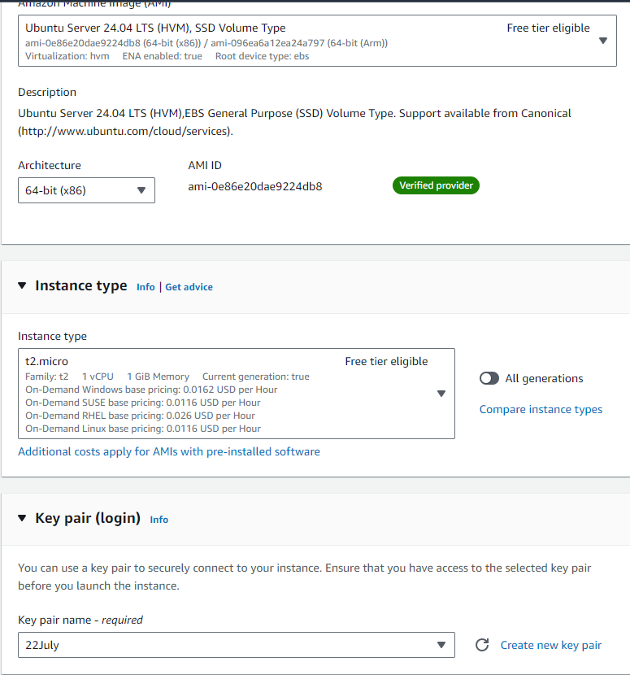

Under Network settings > Click Edit and attach our VPC and under subnet select the public subnet and auto assign public IP enable.

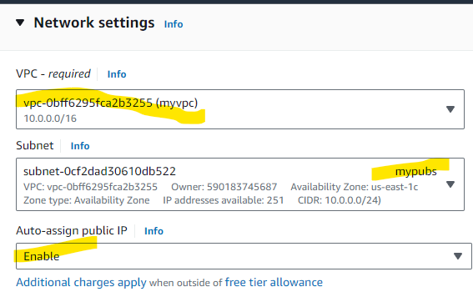

Under Security Groups > Create security group and give it the name mypubsg and allow HTTPS and SSH.

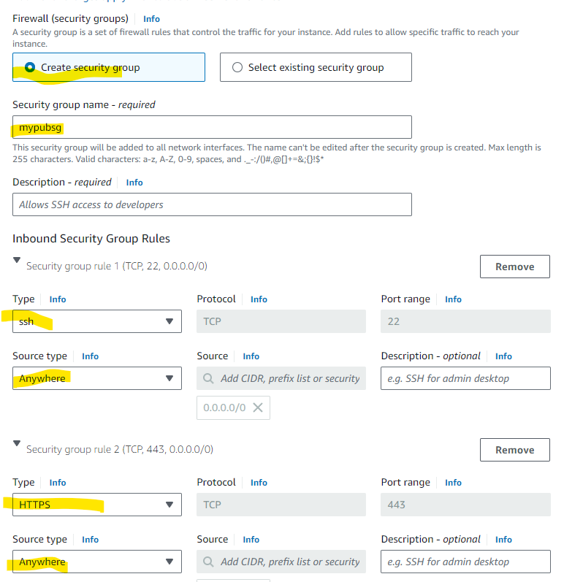

Rest, keep everything as default and click launch instance. We will verify the details once the instance is up.

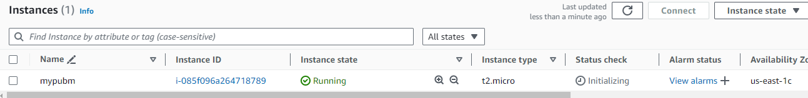

Once the instance is up, we will connect to it via SSH and then run

ping [www.google.com](http://www.google.com) to see if it responds



Checked and verified that ping is responding to www.google.com 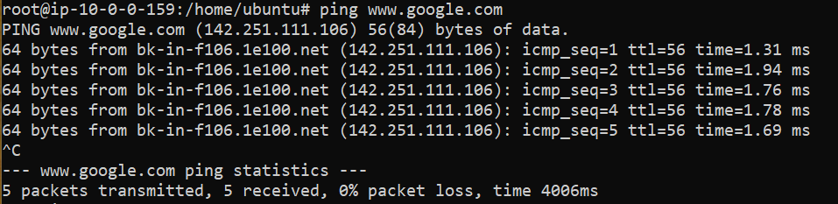

So, internet is working properly on EC2 connected to Public Subnet which is attached to Internet gateway

* Similarly, we will create an EC2 instance on our VPC (myvpc) under private subnet (myprvs) along with new security group name myprvsg, where we will allow SSH and HTTPS port on the inbound rules, so that we can check the internet connectivity is working on the it or not.

Launch an instance



Now fill in the details with name as myprvm (my private machine), select OS as ubuntu

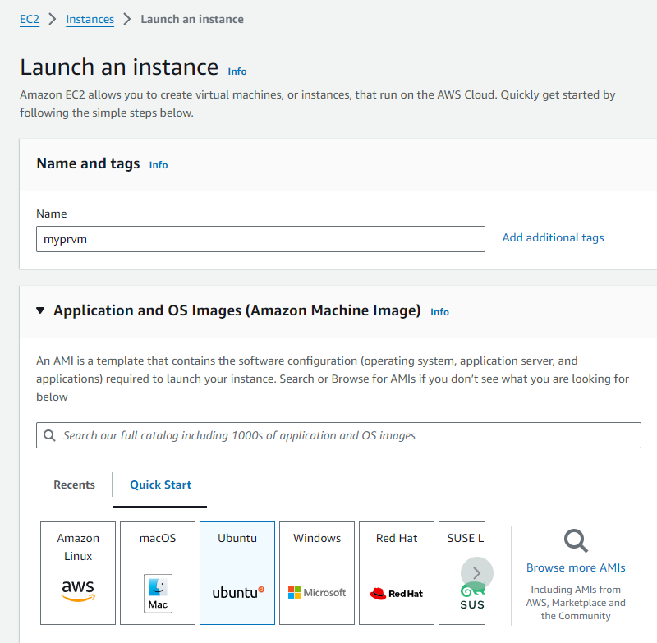

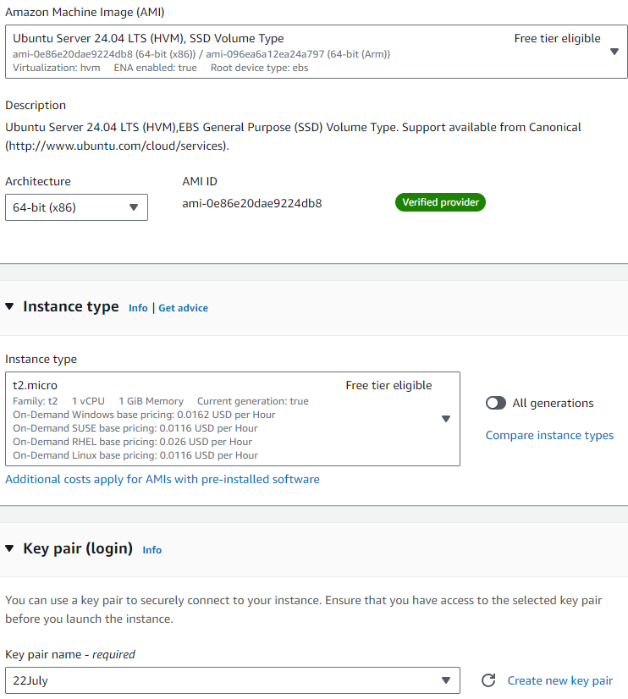

Under Network settings > Click Edit and attach our VPC and under subnet select the private subnet and auto assign public IP disable.

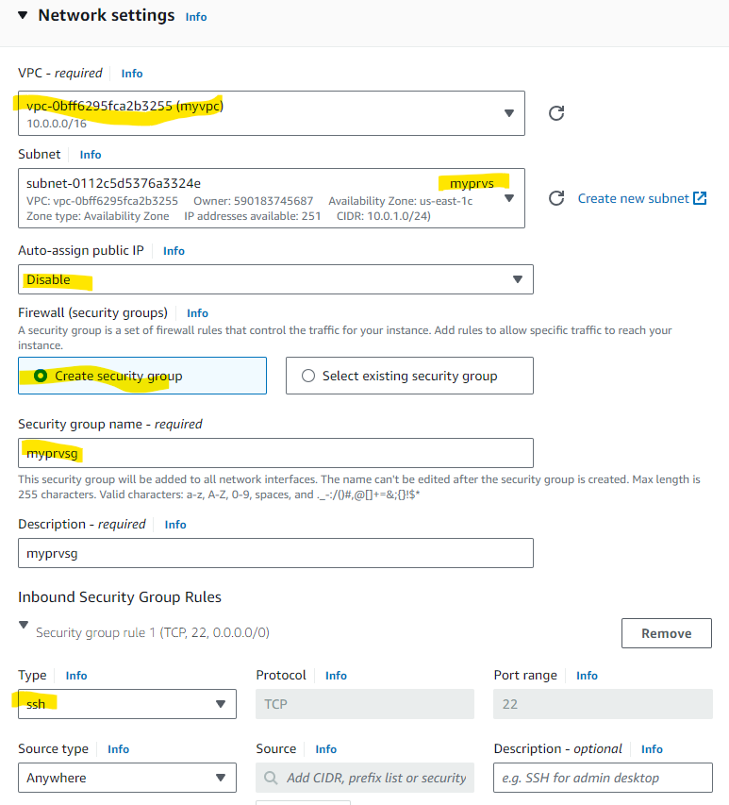

Rest, keep everything as default and click launch instance. We will verify the details once the instance is up.

* Now since the private EC2 instance does not have public IP, we will SSH to private EC2 instance from public EC2 instance.

To make this happen, we need to create the same .pem file i.e. in our case 22july.pem in public instance and copy the contents from the pem file on the local machine.

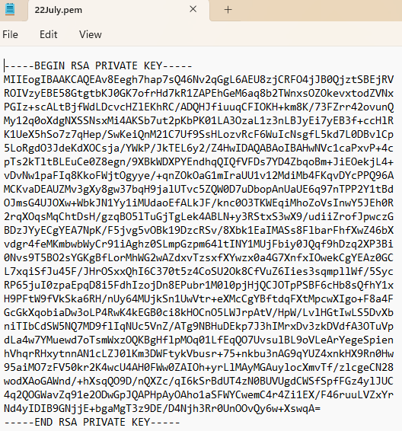

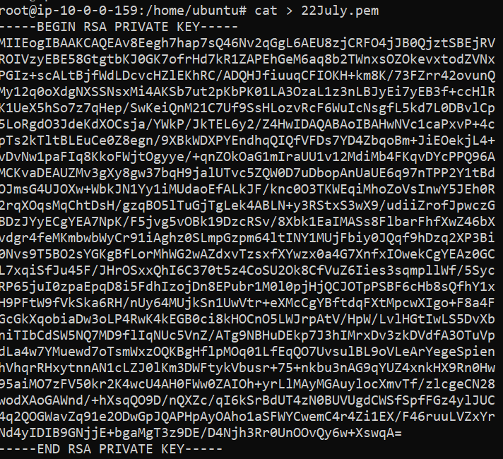

We will also change the permissions of the .pem file created to 400 so that we need it for read purpose by running the command.



Now we will connect to the private instance using the below command.

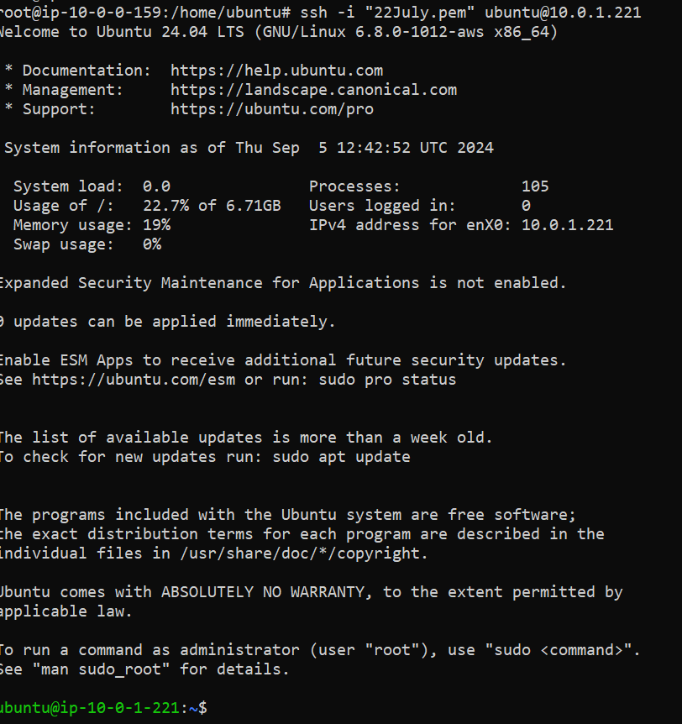

We were able to connect to the private EC2 instance successfully.

Now we will check if ping [www.google.com](http://www.google.com) responds or not

Checked and verified that ping is not responding to [www.google.com](http://www.google.com) on the private instance.

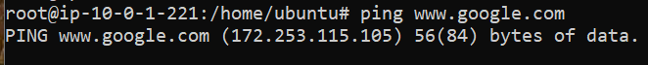

We will also try to install docker.io and see if it works or not.

Docker installation is not working as it usually does, since the machine is in private subnet and nothing open to internet.

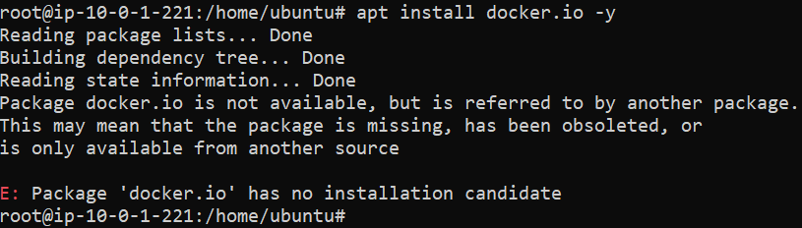

* If we want to download and install docker on private ec2 instance without access to internet, we need to create a NAT gateway.
* In AWS console, search for VPC and click on it.



* Now we will go to NAT Gateway under VPC dashboard.

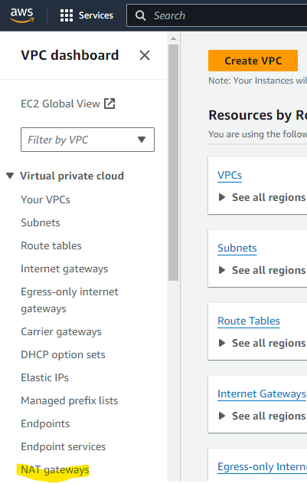

* Click Create NAT Gateway.

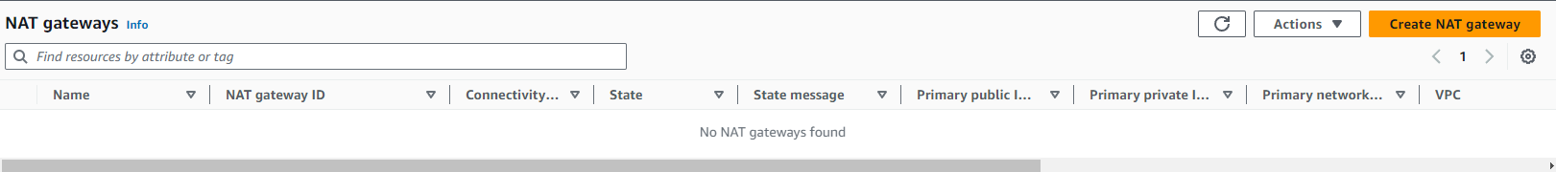

* Now under NAT Gateway Settings, give the name as myngw (My NAT Gateway)

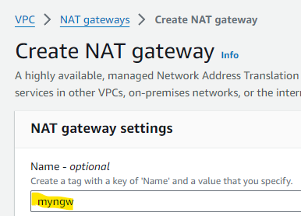

* Under Subnet, we will select our Public Subnet (mypubs) since we need internet from public subnet as it is connected to internet gateway, keep connectivity type as public and allocate Elastic IP and click create NAT Gateway.

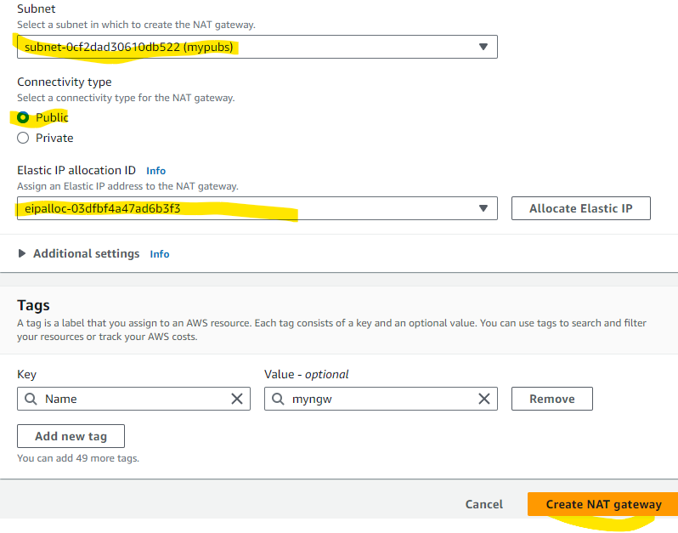

NAT Gateway is created successfully.

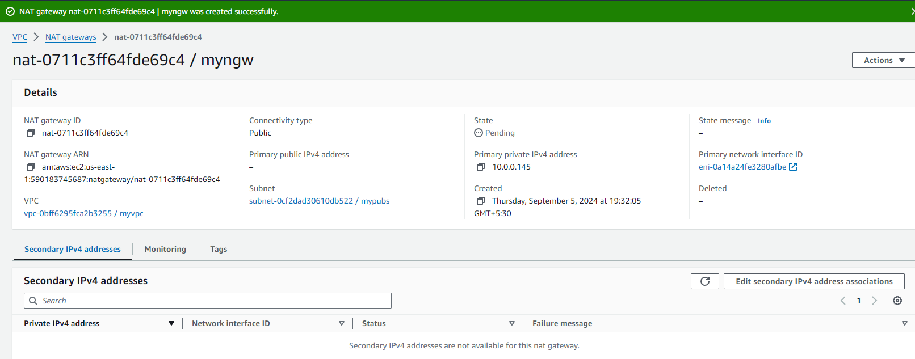

* Now again we will go to Route tables and under our Public Route Table (myprvrt) > Routes > Edit Routes

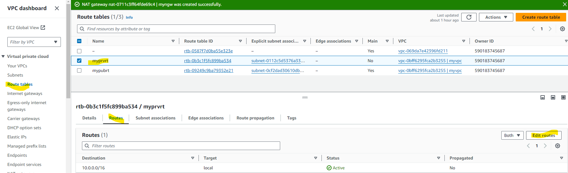

Click on Add Route

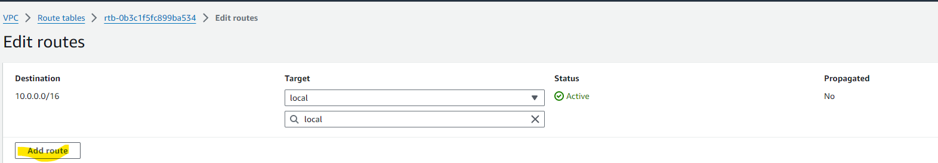

Under Destination we will give 0.0.0.0/0 and under target we will give internet gateway and attach the NAT gateway (myngw) that we created and click save changes.

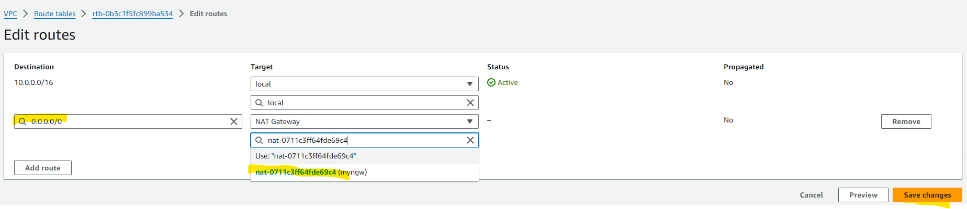

* Now we will do ssh again to private instance and see if we are able to get to the internet by masking through NAT Gateway by installing docker.io on the private instance using the below command.

apt update -y && apt upgrade -y && apt install docker.io -y

Now we can see that docker.io got installed successfully.

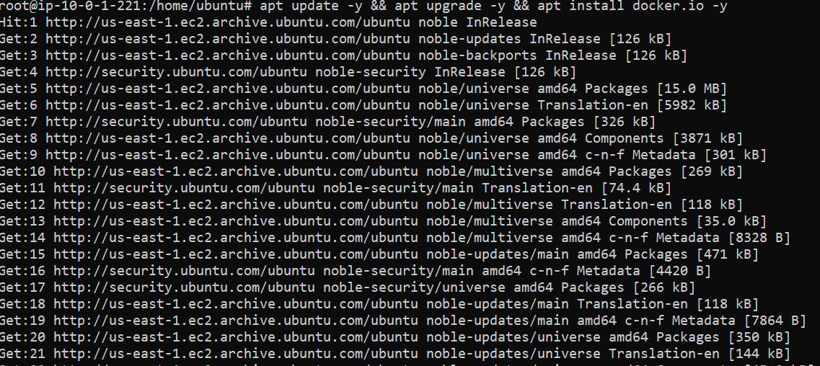

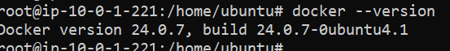

* This states that docker is installed successfully without internet.

1. **Create a customized container in an EC2 Instance where we need to perform below tasks**

* Create a index.html file with contents (Your container created very good) on the EC2 instance.
* Create a nginx container on port 80:80.
* Location where we need to copy the index.html file from host to container so that we will get the required output on WebURL.
* Copy the index.html file to the required location and verify that we are getting the required output on WebURL.
* We also need to cat the index.html contents in the container and its output should print outside the container.
* Before we proceed for any of the tasks, we need to have an EC2 instance with docker installed on it.



* **Create a index.html file with contents (Your container created very good) on the EC2 instance.**

Create an index.tml file by using the below command.

vi index.html

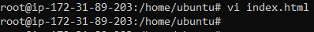

Copy and paste the below contents in index.html file

<!DOCTYPE html>

<html>

<head>

</head>

<body>

<h1>Your contaniner created very good !!</h1>

</body>

</html>

Esc wq! (Escape, Write Quit and save the file)

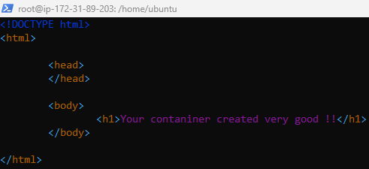

Index.html file is successfully created and placed under /home/ubuntu and we verified by doing ls -ltr

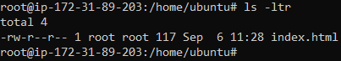

* **Create a nginx container on port 80:80**

We pulled and run a nginx image which created a container by running the below command.

docker run -d -p 80:80 --restart always --name nginxtest nginx

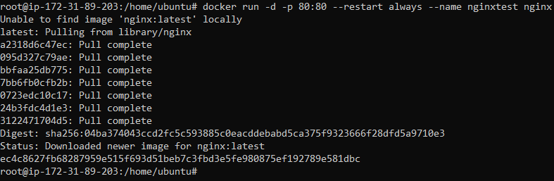

We will verify the container details by running the below command

docker ps



We checked on Web URL to confirm that nginx was running properly.

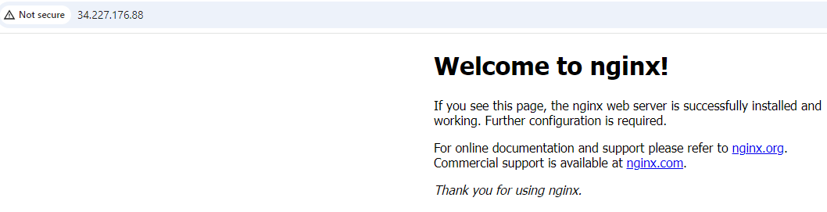

* **Location where we need to copy the index.html file from host to container so that we will get the required output on WebURL.**

The location where we need to put our index.html file is as below:

**/usr/share/nginx/html**

* **Copy the index.html file to the required location in the container and verify that we are getting the required output on WebURL.**

To perform the copy from host to container, we will run the below command.

docker cp /home/ubuntu/index.html ec4c8627fb68:/usr/share/nginx/html/

(Command copies the index.html file from source(host) location to destination(container) location using container id)



Above command shows that copy was successful.

Now we will verify that changes are reflected on WebURL after our index.html file is copied on the container location.

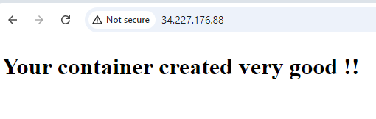

The output is as expected.

* **We also need to cat the index.html contents in the container and its output should print outside the container.**

We will use the below command to cat the index.html inside the container and print the output on the host.

docker exec ec4c8627fb68 sh -c 'cat < /usr/share/nginx/html/index.html'

(Command will exec the container using container id and execute shell to cat the index.html on the mentioned location)

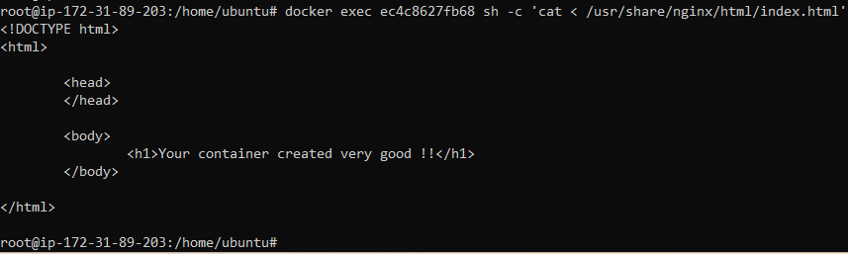

1. **Docker swarm Installation and worker join installation script**

* To run docker swarm installation and worker join script we need the below prerequisites.
* At least 3 EC2 Instances with docker installed on them by adding the commands on the user data. One instance will be called as master (leader) and other two instances will be worker nodes.
* We need to create a “test” user on all 3 EC2 instances with the command so that their home directory is also created.
* Provide “test” user root level access with a script on all 3 EC2 instances.
* We need to create a temporary file “tempUserName.txt” for passing “test” user details on master EC2 instance.
* We need to create a file by name “ipaddr” which will contain the Public ip address of worker nodes on master EC2 instance.
* We need to setup password less authentication between master and worker nodes from the master instance using script.
* Performing Prerequisites
* **Creating 3 EC2 instances with ubuntu and docker installed with all the packages up to date using the commands in the user data mentioned in the below screenshot.**

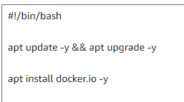

Below are the 3 EC2 Instances. DM (Master), DW1 (Worker Node 1) and DW2 worker. We have also set the hostnames accordingly to avoid any confusion.

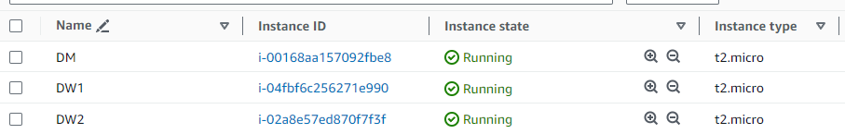

* **Creating a “test” user on all 3 EC2 instances with the command so that their home directory is also created.**

**Master Node (DM)**

useradd -p abc123 -m test (Command for creating test with unencrypted password using **-p** and creating home directory using **-m**)

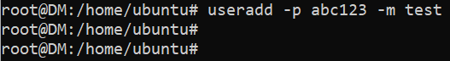

We need to reset the password once for the test user to give it an encrypted password. Since, we have setup and unencrypted password using the below command.

passwd test (command to reset the password for the user)

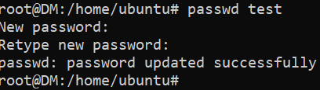

Now we will also verify home directory is created for the test user or not by using the below command.

cd /home/test (Command to change directory)

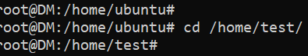

Home directory created and verified

Same Steps needs to be done on worker nodes as well.

**Worker Node 1 (DW1)**

useradd -p abc123 -m test (Command for creating test with unencrypted password using **-p** and creating home directory using **-m**)



We need to reset the password once for the test user to give it an encrypted password. Since, we have setup and unencrypted password using the below command.

passwd test (command to reset the password for the user)

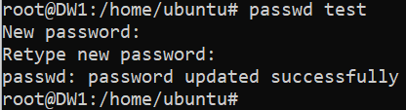

Now we will also verify home directory is created for the test user or not by using the below command.

cd /home/test (Command to change directory)

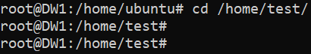

Home directory created and verified

**Worker Node 2 (DW2)**

useradd -p abc123 -m test (Command for creating test with unencrypted password using **-p** and creating home directory using **-m**)

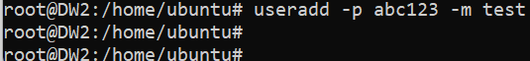

We need to reset the password once for the test user to give it an encrypted password. Since, we have setup and unencrypted password using the below command.

passwd test (command to reset the password for the user)

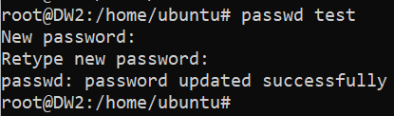

Now we will also verify home directory is created for the test user or not by using the below command.

cd /home/test (Command to change directory)

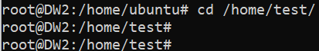

Home directory created and verified

**NOTE: After creating test user, we need to perform all the tasks from home directory of test**

* **Providing “test” user root level access with a script which we need to run on all 3 EC2 instances.**

**Master Node (DM)**

Create a shell script with any name, in my case I created “rootlevel.sh”. Edit the file and enter the below contents in that file.

vi rootlevel.sh (Edit the file)

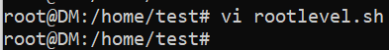

**Contents of the script**

#!/bin/bash

# Uncomment the file to allow password authentication

sed -i '/PasswordAuthentication yes/s/^#//g' /etc/ssh/sshd\_config

# Add below paramaters in the cloud sshd file

echo "PasswordAuthentication yes" > /etc/ssh/sshd\_config.d/60-cloudimg-settings.conf

echo -e "PermitRootLogin yes" >> /etc/ssh/sshd\_config.d/60-cloudimg-settings.conf

# Giving same permissions as root to test

echo "test ALL=(ALL:ALL) ALL" > a.txt

sed -i '47r a.txt' /etc/sudoers

# SSH Service Restart

systemctl restart ssh



Run the script as bash and test user will have same level of access as root

bash rootlevel.sh

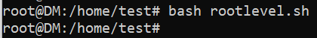

Same steps needed to done on other worker nodes.

**Worker Node 1 (DW1)**

Create a shell script with any name, in my case I created “rootlevel.sh”. Edit the file and enter the below contents in that file.

vi rootlevel.sh (Edit the file)

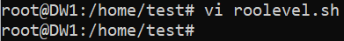

**Contents of the script**

#!/bin/bash

# Uncomment the file to allow password authentication

sed -i '/PasswordAuthentication yes/s/^#//g' /etc/ssh/sshd\_config

# Add below paramaters in the cloud sshd file

echo "PasswordAuthentication yes" > /etc/ssh/sshd\_config.d/60-cloudimg-settings.conf

echo -e "PermitRootLogin yes" >> /etc/ssh/sshd\_config.d/60-cloudimg-settings.conf

# Giving same permissions as root to test

echo "test ALL=(ALL:ALL) ALL" > a.txt

sed -i '47r a.txt' /etc/sudoers

# SSH Service Restart

systemctl restart ssh



Run the script as bash and test user will have same level of access as root

bash rootlevel.sh

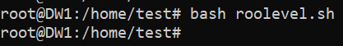

**Worker Node 2 (DW2)**

Create a shell script with any name, in my case I created “rootlevel.sh”. Edit the file and enter the below contents in that file.

vi rootlevel.sh (Edit the file)

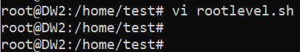

**Contents of the script**

#!/bin/bash

# Uncomment the file to allow password authentication

sed -i '/PasswordAuthentication yes/s/^#//g' /etc/ssh/sshd\_config

# Add below paramaters in the cloud sshd file

echo "PasswordAuthentication yes" > /etc/ssh/sshd\_config.d/60-cloudimg-settings.conf

echo -e "PermitRootLogin yes" >> /etc/ssh/sshd\_config.d/60-cloudimg-settings.conf

# Giving same permissions as root to test

echo "test ALL=(ALL:ALL) ALL" > a.txt

sed -i '47r a.txt' /etc/sudoers

# SSH Service Restart

systemctl restart ssh



Run the script as bash and test user will have same level of access as root

bash rootlevel.sh

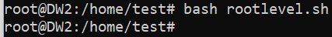

* **Creating a temporary file “tempUserName.txt” for passing “test” user details on master EC2 instance.**

echo "test" > tempUserName.txt (Command creates tempUserName.txt and puts test as text inside)



* **Creating a file by name “ipaddr” which will contain the Public ip address of worker nodes on master EC2 instance.**

echo "34.201.144.186" > ipaddr (Command creates ipaddr file and puts the ip address as text inside)



echo "54.226.167.198" >> ipaddr (Command appends existing ipaddr file and puts the ip address as text inside)



* **Setting up password less authentication between master and worker nodes from the master instance using script.**

**Master Node (DM)**

Create a shell script with any name, in my case I created “passwordless\_ssh.sh”. Edit the file and enter the below contents in that file.

vi passwordless\_ssh.sh (Edit the file)



Contents of the script

#!/bin/bash

# Defining variable for ipaddr file

ipAddFile="./ipaddr"

# Command runs SSH-Keygen without prompting anything

echo -e "\n" | ssh-keygen -N "" &> /dev/null

# Now the Script checks the IP address file and concat the username and IP address to copy the ssh pub key

echo "$ipAddFile"

for IP in `cat $ipAddFile`; do

if [[ $IP == \*"["\* ]]; then

echo "$IP"|cut -d "[" -f2 | cut -d "]" -f1>tempUserName.txt

else

user=$(cat tempUserName.txt)

ssh-copy-id $user@$IP

echo "Key copied to $IP"

fi

done

# Remove tempUserName.txt file

rm -rf tempUserName.txt



Run the script as bash and passwordless SSH will be setup between master and worker nodes

bash passwordless\_ssh.sh 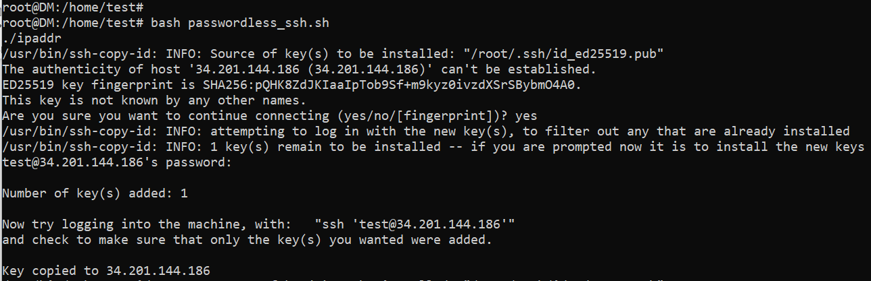

We need to supply password for test user to get the key copied (Above screenshot shows key copied to first IP address in ipaddr file)

Continuing the script, pasting the screenshot for second IP address

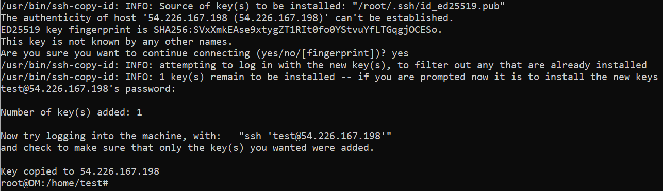

We need to supply password for test user to get the key copied (Above screenshot shows key copied to second IP address in ipaddr file)

Passwordless ssh has been setup correctly.

* Add the “test” user to docker group so that, our main script gets executed all 3 EC2 instances.

usermod -a -G docker test (command to add test user to the docker group as is not a member of the docker group)

**Master Node (DM)**



**Worker Node 1 (DW1)**

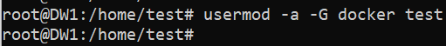

**Worker Node 2 (DW2)**

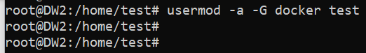

All the Pre-requisites have been completed.

* Now we will run the final script to initialize docker swarm and join worker node to docker swarm and verifying the same.

**MAIN SCRIPT on Master Node (DM)**

Create a shell script with any name, in my case I created “docker\_swarm.sh”. Edit the file and enter the below contents in that file.

vi docker\_swarm.sh (Edit the file)

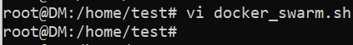

Contents of the script

#!/bin/bash

# Initialize Docker Swarm and copy the output to text file

docker swarm init > /home/test/output.txt

# Extract the token line required to join worker node

sed -n -e 5p /home/test/output.txt > /home/test/out.txt

# Add the bin bash to the line so that it acts as a shell script

sed '1 i\ #!/bin/bash' /home/test/out.txt > /home/test/final.sh

# Now execute the final shell script on the worker nodes

for server in $(cat /home/test/ipaddr)

do

ssh test@${server} 'bash -s' < /home/test/final.sh

done

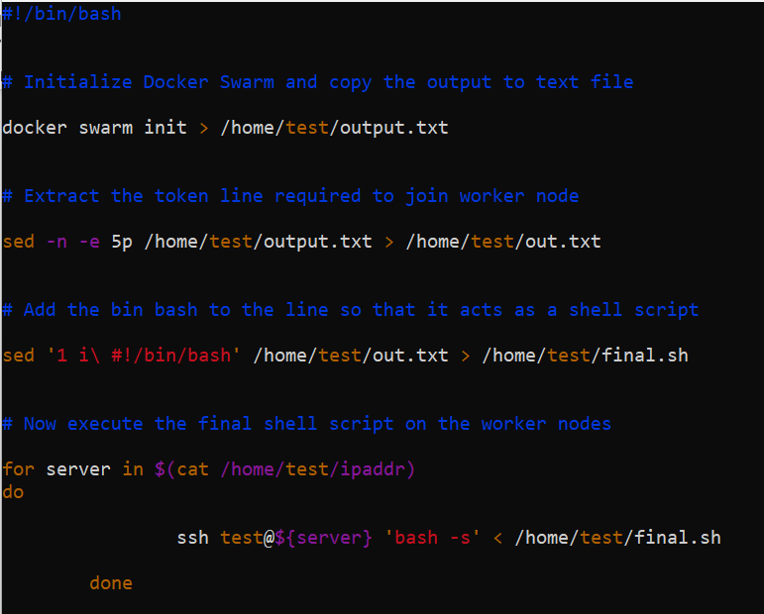

Run the script as bash and docker swarm script on the master node.

bash docker\_swarm.sh

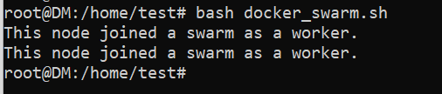

Docker swarm initialized successfully and worker node also joined to docker swarm

We will verify the above by running the below command on master node.

docker node ls (Command to list the nodes of docker swarm)

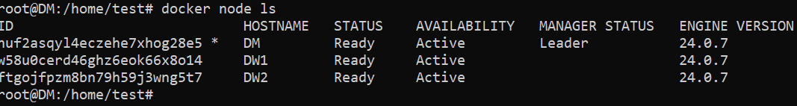

Successfully verified that docker swarm initialized and worker node also joined to docker swarm.